Acceptance tests   
Acme-Packages 1.0

|  |  |
| --- | --- |
| ****Development team**** | |
| **Identifier** | G26 |
| **Members** | Valero García, Luis; de los Reyes García, José Manuel; Mora Carrero, Adrián; Mohamed Pérez, Abdelha; Muñoz Espejo, Domingo |
| **Testing team** | |
| **Identifier** | G98 |
| **Members** | Salguero Álvarez, Tania; Lopez Heredia, Gonzalo; Serrano Férnandez, Damián; Lozano Tore, Carlos; Cuevas Carrasco, David |
| **Indexing data** | |
| **Test designers** | Valero García, Luis; de los Reyes García, José Manuel; Mora Carrero, Adrián; Mohamed Pérez, Abdelha; Muñoz Espejo, Domingo |
| **Testers** | Salguero Álvarez, Tania; Lopez Heredia, Gonzalo; Serrano Férnandez, Damián; Lozano Tore, Carlos; Cuevas Carrasco, David |
| **Notes** |  |

Table of contents

Use case UC01 List of positions 4

Use case UC02 Display of positions 5

Use case UC03 Manage of positions 6

Use case UC04 List of curricula 10

Use case UC05 Display of curriculum 11

Use case UC06 Manage of curriculum 12

Use case UC07 Display of miscellaneous data 14

Use case UC08 Manage of miscellaneous data 15

Use case UC09 Display of position data 18

Use case UC10 Manage of position data 18

Use case UC11 Manage of educational data 21

Use case UC12 List by tags. 24

Use case UC13 Send a message. 25

Use case UC14 Send a broadcast message. 28

Use case UC15 Search by tags. 30

Use case UC16 Display a message. 32

Use case UC17 Delete a message. 34

Use case UC18 List sponsorships. 37

Use case UC19 Create a sponsorship. 38

Use case UC20 Edit a sponsorship. 40

Use case UC21 Delete a sponsorship. 42

Use case UC22 List items. 44

Use case UC23 Display an item. 45

Use case UC24 Create an item. 46

Use case UC25 Edit an item. 48

Use case UC26 Delete an item. 51

Use case UC27 List problems. 53

Use case UC29 Display problems. 55

Use case UC30 Create a problem. 56

Use case UC31 Edit a problem. 59

Use case UC32 Delete a problem. 62

Use case UC33 List social profile. 64

Use case UC34 Create a social profile. 66

Use case UC35 Edit a social Profile. 68

Use case UC36 Delete a social profile. 71

Use case UC37 Display dashboard. 72

Use case UC38 Calculate spammers, compute companies audit score and send rebranding notification. 74

Use case UC39 Ban actors 76

Use case UC40 List audits from positions. 76

Use case UC41 Display an audit. 78

Use case UC42 Create an audit. 79

Use case UC43 Edit an audit. 81

Use case UC44 Delete an audit. 82

Use case UC45 Edit configuration. 83

Use case UC46 List applications. 86

Use case UC47 Create an application. 87

Use case UC48 Edit application. 88

Use case UC49 Register as user 90

Use case UC50 Create a user being an administrator 109

Use case UC51 Display personal data 112

Use case UC52 Manage personal data 114

Use case UC53 Finder 117

Use case UC54 List of companies 119

Use case UC55 List of providers 120

Additional tests 122

# Use case UCXX List of curricula

Description

Every rookie can list its curricula.

Access

By clicking in “Curricula” in the navigation bar.

Tests

|  |  |
| --- | --- |
| **Test 001** | |
| **Description** | A logged rookie wants to see its curricula. |
| **Expected** | A list page with the curriculums of the rookie (rookie1). |
| **Outcome** | El sistema muestra los curriculums del usuario. |
| **Notes** |  |

# Use case UCXX Display of curriculum

Description

Rookies can display its curriculums.

Access

By clicking in “Curricula” in the navigation bar and selecting one of the created curriculums clicking in the “Full name” field.

Tests

|  |  |
| --- | --- |
| **Test 001** | |
| **Description** | A logged rookie wants to see one of its curriculums. |
| **Expected** | A display of the selected curriculum (id=561). |
| **Outcome** | El sistema muestra los datos del curriculum seleccionado. |
| **Notes** |  |

# Use case UCXX Manage of curriculum

Description

Rookies can manage its curriculums.

Access

By clicking in “Curricula” in the navigation bar.

Tests

|  |  |
| --- | --- |
| **Test 001** | |
| **Description** | A logged rookie wants to create a new curriculum, so it clicks the “Create” link at the bottom. Once inside he enters the personal data. |
| **Expected** | If the data is correct the system will redirect to the display of the new curriculum. |
| **Outcome** | Al introducir datos correctos en el formulario, el sistema crea el curriculum y redirige a una vista con dichos datos. |
| **Notes** |  |

|  |  |
| --- | --- |
| **Test 002** | |
| **Description** | A logged rookie wants to create a new curriculum, so it clicks the “Create” link at the bottom. Once inside he enters incorrect data. |
| **Expected** |  |
| **Outcome** | El sistema muestra los errores esperados. |
| **Notes** |  |

|  |  |
| --- | --- |
| **Test 003** | |
| **Description** | A logged rookie wants to edit one of his curriculums, so it clicks the link in the column “Full name” to enter in its display view. Once inside the rookie clicks the edit link of the personal data. |
| **Expected** | If the data is correct, the system will redirect to the display view. |
| **Outcome** | El sistema edita correctamente el curriculum si introducimos datos correctos, posteriormente nos lleva a una vista con dichos datos |
| **Notes** |  |

|  |  |
| --- | --- |
| **Test 004** | |
| **Description** | A logged rookie wants to delete one of his curriculums, so in the edit view he clicks the delete button. |
| **Expected** | If everything is OK, the system will redirect to the list page. A confirmation is required. |
| **Outcome** | El sistema elimina el curriculum y redirige a la página del listado de curriculums, donde el curriculum eliminado ya no aparece. |
| **Notes** |  |

# POSTERIORES A ESTO SE BORRARÁ

# Use case UC01 List of positions

Description

Every actor of the system can list the available positions.

Access

By clicking in the field “Positions” in the navigation bar or in “My positions” in case that a company or an auditor actor wants to see its positions.

Tests

|  |  |
| --- | --- |
| **Test 001** | |
| **Description** | A logged or non-logged actor wants to see the available positions. |
| **Expected** | A list page with positions in final mode and not cancelled. The pagination should work. |
| **Outcome** | El sistema muestra las posiciones esperadas, tanto logueado como no logueado. La paginación funciona correctamente |
| **Notes** |  |

|  |  |
| --- | --- |
| **Test 002** | |
| **Description** | A logged or non-logged actor wants to see the available positions that matches an entered keyword. |
| **Expected** | A list page with positions in final mode and not cancelled that matches the entered keyword. By searching “node” we get: |
| **Outcome** | El sistema busca correctamente por una palabra clave tanto logueado como no logueado en el sistema. |
| **Notes** |  |

|  |  |
| --- | --- |
| **Test 003** | |
| **Description** | A company user wants to see its positions. |
| **Expected** | By clicking in “My positions” we get all the positions created by the logged company (company1 in this case). |
| **Outcome** | Logueado con las credenciales company/company podemos listar nuestras posiciones. |
| **Notes** |  |

|  |  |
| --- | --- |
| **Test 004** | |
| **Description** | An auditor user wants to see its assigned positions. |
| **Expected** | By clicking in “My positions” we get all the positions assigned to the logged auditor (auditor1 in this case). |
| **Outcome** | Logueado con las credenciales auditor1/auditor1 podemos ver nuestras posiciones asignadas. |
| **Notes** |  |

# Use case UC02 Display of positions

Description

Every actor of the system can display the available positions.

Access

By clicking in the ticker of a position inside the listing page.

Tests

|  |  |
| --- | --- |
| **Test 001** | |
| **Description** | A logged or non-logged actor wants to see a position |
| **Expected** | The third position in the list (with id=505) should have the following information. |
| **Outcome** | No se muestra un link hacia la lista de “audits” de esa position |
| **Notes** |  |

|  |  |
| --- | --- |
| **Test 002** | |
| **Description** | A logged rookie wants to see the display of an available position. |
| **Expected** | The display of the third position in the list (with id=505) should show the following to the logged rookie. |
| **Outcome** | No se muestra un link hacia la lista de “audits” de esa position |
| **Notes** |  |

# Use case UC03 Manage of positions

Description

The companies of the system can manage their positions

Access

A logged company can access to his control panel of positions by clicking in the field “My positions” in the navigation bar. So, the company1 will see:

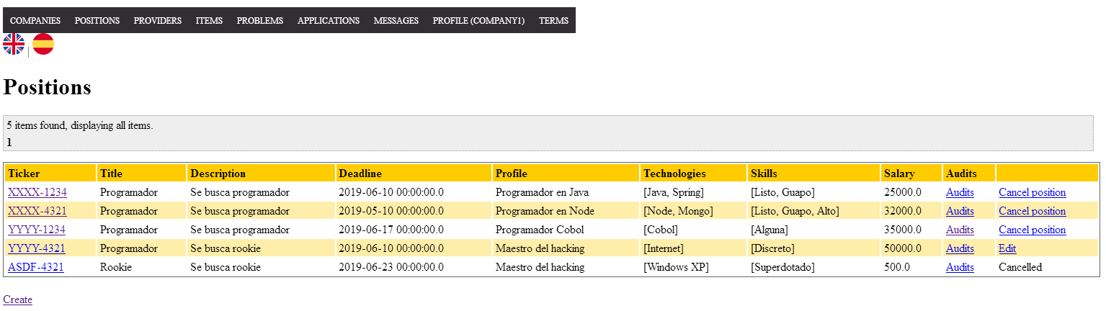

Tests

|  |  |
| --- | --- |
| **Test 001** | |
| **Description** | A logged company wants to create a new position. The form is accessed by the “Create” link and the entered data is correct. |
| **Expected** | Once created the display page of the new position will be showed. The ticker is created automatically and should follow a pattern. |
| **Outcome** | Introduciendo datos correctos, la posición se crea y se muestra posteriormente. |
| **Notes** |  |

|  |  |
| --- | --- |
| **Test 002** | |
| **Description** | A logged company wants to create a new position but clicks the save button without changing anything. |
| **Expected** | The system will reload the page showing all these errors. |
| **Outcome** | Sin introducir datos, se muestran los errores esperados. |
| **Notes** |  |

|  |  |
| --- | --- |
| **Test 003** | |
| **Description** | A logged company wants to create a new position in final mode but doesn’t pick two problems at least. |
| **Expected** | The system will reload the page showing this error. |
| **Outcome** | El sistema no permite poner una posición en modo final si no se seleccionan al menos dos problemas. Se muestra el error esperado. |
| **Notes** |  |

|  |  |
| --- | --- |
| **Test 004** | |
| **Description** | A logged company wants to edit one of his positions (cannot be in final mode) by clicking in the edit button in the “My positions” view. |
| **Expected** | It will show the form with the same restrictions than the creation one. It will redirect to the display if the data is correct. |
| **Outcome** | Con datos correctos, el sistema permite la modificación y redirige a una vista con sus datos. |
| **Notes** |  |

|  |  |
| --- | --- |
| **Test 005** | |
| **Description** | A logged company wants to cancel a position (it needs to be in final mode). |
| **Expected** | Once clicked the “Cancel position” link in the “My positions” view the system will reload the same page but the link will no longer be there, instead it will appear a message saying “Cancelled”. |
| **Outcome** | El sistema cancela la posición como se espera. |
| **Notes** |  |

|  |  |
| --- | --- |
| **Test 006** | |
| **Description** | A logged company wants to delete a position (cannot be in final mode). |
| **Expected** | Once clicked the “Edit button” link in the “My positions” view the system will load the edit form. By clicking the delete button the system will redirect to the “My positions” view and the deleted position will not appear. The system will ask for confirmation. |
| **Outcome** | Se elimina la posición seleccionada y no aparece en el listado que se recarga. |
| **Notes** |  |

# Use case UC04 List of curricula

Description

Every rookie can list its curricula.

Access

By clicking in “Curricula” in the navigation bar.

Tests

|  |  |
| --- | --- |
| **Test 001** | |
| **Description** | A logged rookie wants to see its curricula. |
| **Expected** | A list page with the curriculums of the rookie (rookie1). |
| **Outcome** | El sistema muestra los curriculums del usuario. |
| **Notes** |  |

# Use case UC05 Display of curriculum

Description

Rookies can display its curriculums.

Access

By clicking in “Curricula” in the navigation bar and selecting one of the created curriculums clicking in the “Full name” field.

Tests

|  |  |
| --- | --- |
| **Test 001** | |
| **Description** | A logged rookie wants to see one of its curriculums. |
| **Expected** | A display of the selected curriculum (id=561). |
| **Outcome** | El sistema muestra los datos del curriculum seleccionado. |
| **Notes** |  |

# Use case UC06 Manage of curriculum

Description

Rookies can manage its curriculums.

Access

By clicking in “Curricula” in the navigation bar.

Tests

|  |  |
| --- | --- |
| **Test 001** | |
| **Description** | A logged rookie wants to create a new curriculum, so it clicks the “Create” link at the bottom. Once inside he enters the personal data. |
| **Expected** | If the data is correct the system will redirect to the display of the new curriculum. |
| **Outcome** | Al introducir datos correctos en el formulario, el sistema crea el curriculum y redirige a una vista con dichos datos. |
| **Notes** |  |

|  |  |
| --- | --- |
| **Test 002** | |
| **Description** | A logged rookie wants to create a new curriculum, so it clicks the “Create” link at the bottom. Once inside he enters incorrect data. |
| **Expected** |  |
| **Outcome** | El sistema muestra los errores esperados. |
| **Notes** |  |

|  |  |
| --- | --- |
| **Test 003** | |
| **Description** | A logged rookie wants to edit one of his curriculums, so it clicks the link in the column “Full name” to enter in its display view. Once inside the rookie clicks the edit link of the personal data. |
| **Expected** | If the data is correct, the system will redirect to the display view. |
| **Outcome** | El sistema edita correctamente el curriculum si introducimos datos correctos, posteriormente nos lleva a una vista con dichos datos |
| **Notes** |  |

|  |  |
| --- | --- |
| **Test 004** | |
| **Description** | A logged rookie wants to delete one of his curriculums, so in the edit view he clicks the delete button. |
| **Expected** | If everything is OK, the system will redirect to the list page. A confirmation is required. |
| **Outcome** | El sistema elimina el curriculum y redirige a la página del listado de curriculums, donde el curriculum eliminado ya no aparece. |
| **Notes** |  |

# Use case UC07 Display of miscellaneous data

Description

Rookies can see the miscellaneous data of its curriculums.

Access

By clicking in “Curricula” in the navigation bar and selecting one of its curriculums (the link in the “Full name” column).

Tests

|  |  |
| --- | --- |
| **Test 001** | |
| **Description** | A logged rookie wants to see the miscellaneous data of one of its curriculums (with rookie1, select the first curriculum). |
| **Expected** | The display of the data is embedded inside the display of the curriculum.    If the curriculum does not have miscellaneous data it will look like this: |
| **Outcome** | El sistema muestra los datos esperados. |
| **Notes** |  |

# Use case UC08 Manage of miscellaneous data

Description

Rookies can manage the miscellaneous data of its curriculums.

Access

By clicking in “Curricula” in the navigation bar and selecting one of its curriculums (the link in the “Full name” column).

Tests

|  |  |
| --- | --- |
| **Test 001** | |
| **Description** | A logged rookie wants to add a miscellaneous data (with rookie1 select the second curriculum and click the “Add” link at the bottom of the page). |
| **Expected** | The entered data is correct, so the system will redirect to the display of the curriculum. |
| **Outcome** | Si introducimos datos correctos, se crea y nos dirige a una vista con dichos datos. |
| **Notes** |  |

|  |  |
| --- | --- |
| **Test 002** | |
| **Description** | A logged rookie wants to add a miscellaneous data (with rookie1 select the second curriculum and click the “Add” link at the bottom of the page). |
| **Expected** | The entered data is incorrect, so the errors will be loaded in the form page. |
| **Outcome** | El sistema muestra los errores esperados. |
| **Notes** |  |

|  |  |
| --- | --- |
| **Test 003** | |
| **Description** | A logged rookie wants to edit a miscellaneous data (with rookie1 select the first curriculum and click the “Edit” link at the bottom of the page). |
| **Expected** | If the data is correct, it will redirect to the display of the curriculum. |
| **Outcome** | Si los datos son correctos, el sistema permite la edición y redirige a una vista con dichos datos. |
| **Notes** |  |

|  |  |
| --- | --- |
| **Test 004** | |
| **Description** | A logged rookie wants to remove a miscellaneous data (with rookie1 select the first curriculum and click the “Edit” link at the bottom of the page). |
| **Expected** | Once clicked the delete button, the system must ask for confirmation and redirect to the display of the curriculum. |
| **Outcome** | El sistema lo elimina correctamente. |
| **Notes** |  |

# Use case UC09 Display of position data

Description

Rookies can see the position data of its curriculums.

Access

By clicking in “Curricula” in the navigation bar and selecting one of its curriculums (the link in the “Full name” column).

Tests

|  |  |
| --- | --- |
| **Test 001** | |
| **Description** | A logged rookie wants to see the position data of one of its curriculums (with rookie1, select the first curriculum). |
| **Expected** | The display of the position data’s is embedded inside the display of the curriculum. |
| **Outcome** | El sistema muestra los datos esperados. |
| **Notes** |  |

# Use case UC10 Manage of position data

Description

Rookies can manage the position data of its curriculums.

Access

By clicking in “Curricula” in the navigation bar and selecting one of its curriculums (the link in the “Full name” column).

Tests

|  |  |
| --- | --- |
| **Test 001** | |
| **Description** | A logged rookie wants to add a position data (with rookie1 select the second curriculum and click the “Add” link inside the field set of position data). |
| **Expected** | The entered data is correct, so the system will redirect to the display of the curriculum. |
| **Outcome** | Si los datos son correctos, se crea y se redirige a la vista esperada. |
| **Notes** |  |

|  |  |
| --- | --- |
| **Test 002** | |
| **Description** | A logged rookie wants to add a position data (with rookie1 select the second curriculum and click the “Add” link inside the field set of position data). |
| **Expected** | The entered data is incorrect, so the errors will be loaded in the form page. |
| **Outcome** | El sistema muestra los errores esperados. |
| **Notes** |  |

|  |  |
| --- | --- |
| **Test 003** | |
| **Description** | A logged rookie wants to edit a position data (with rookie1 select the first curriculum and click the “Edit” link of the first position data). |
| **Expected** | If the data is correct, it will redirect to the display of the curriculum. |
| **Outcome** | Si los datos son correctos, el sistema lo edita. |
| **Notes** |  |

|  |  |
| --- | --- |
| **Test 004** | |
| **Description** | A logged rookie wants to remove a position data (with rookie1 select the first curriculum and click the “Edit” link of the first position data). |
| **Expected** | Once clicked the delete button, the system must ask for confirmation and redirect to the display of the curriculum. |
| **Outcome** | El sistema lo elimina correctamente. |
| **Notes** |  |

# Use case UC11 Manage of educational data

Description

Rookies can manage the educational data of its curriculums.

Access

By clicking in “Curricula” in the navigation bar and selecting one of its curriculums (the link in the “Full name” column).

Tests

|  |  |
| --- | --- |
| **Test 001** | |
| **Description** | A logged rookie wants to add an educational data (with rookie1 select the second curriculum and click the “Add” link inside the field set of position data). |
| **Expected** | The entered data is correct, so the system will redirect to the display of the curriculum. |
| **Outcome** | Al introducir datos correctos, se crea y dirige a la vista esperada. |
| **Notes** |  |

|  |  |
| --- | --- |
| **Test 002** | |
| **Description** | A logged rookie wants to add an education data (with rookie1 select the second curriculum and click the “Add” link inside the field set of position data). |
| **Expected** | The entered data is incorrect, so the errors will be loaded in the form page. |
| **Outcome** | El sistema muestra los errores esperados. |
| **Notes** |  |

|  |  |
| --- | --- |
| **Test 003** | |
| **Description** | A logged rookie wants to edit an educational data (with rookie1 select the second curriculum and click the “Edit” link of the second educational data). |
| **Expected** | If the data is correct, it will redirect to the display of the curriculum. |
| **Outcome** | Si introducimos datos correctos, el sistema lo edita y redirige a la vista esperada. |
| **Notes** |  |

|  |  |
| --- | --- |
| **Test 004** | |
| **Description** | A logged rookie wants to remove an educational data (with rookie1 select the second curriculum and click the “Edit” link of the first educational data). |
| **Expected** | Once clicked the delete button, the system must ask for confirmation and redirect to the display of the curriculum. |
| **Outcome** | El sistema lo elimina correctamente. |
| **Notes** |  |

# Use case UC12 List by tags.

Before testing

We will use admin/admin to log into the system. We will use this user account to make testing from UC12-UC17

Description

An authenticated actor can list his/her messages and sort it by tags.

Access

Login > Main menu > Messages > Mess sent > Tags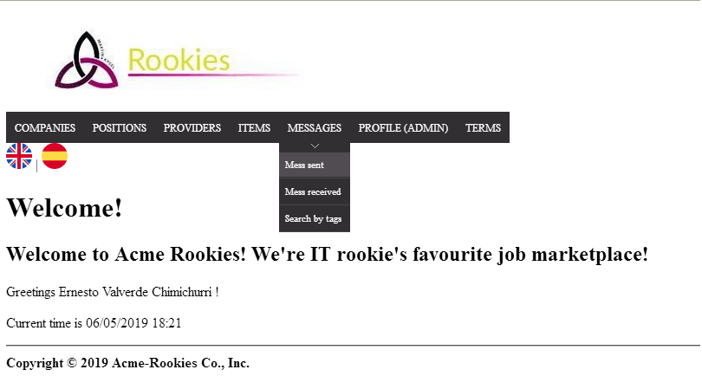

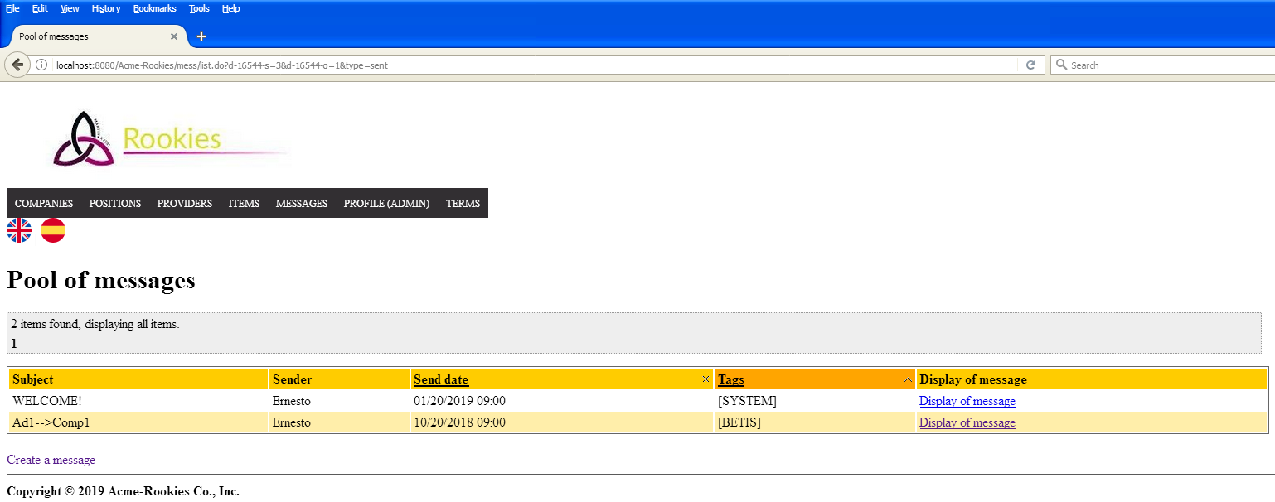

Tests

|  |  |
| --- | --- |
| **Test 001** | |
| **Description** | A user can list his/her messages by tags. |
| **Expected** | The system must return to a view where shows the outbox pool with a list of messages. If user clicks on ‘Tags’, list must be sorted. |
| **Outcome** | El sistema lista los mensajes enviados y permite ordenar por “Tags”. |
| **Notes** |  |

# Use case UC13 Send a message.

Description

An authenticated actor can send a message to an actor.

Access

Login > Main menu > Messages > Mess sent > Create > Send.

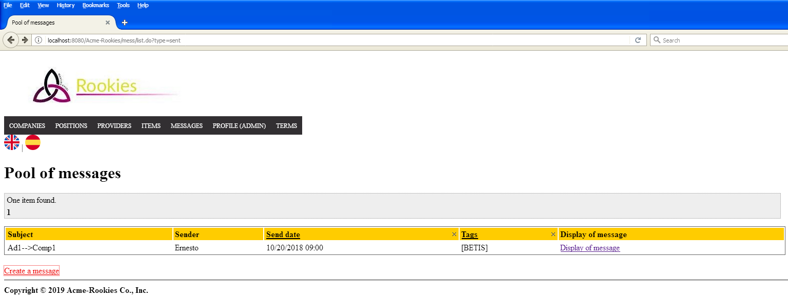

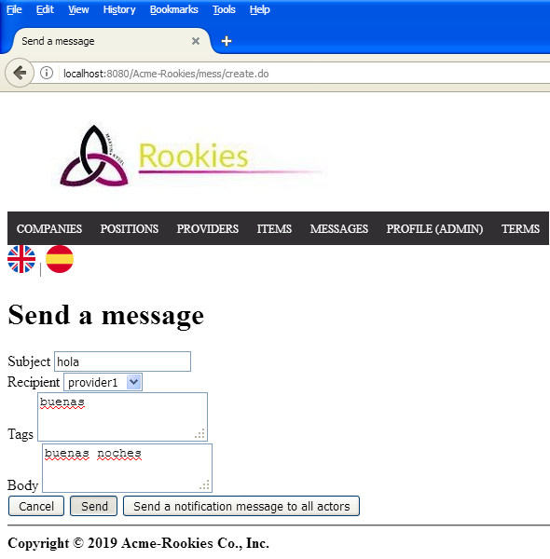

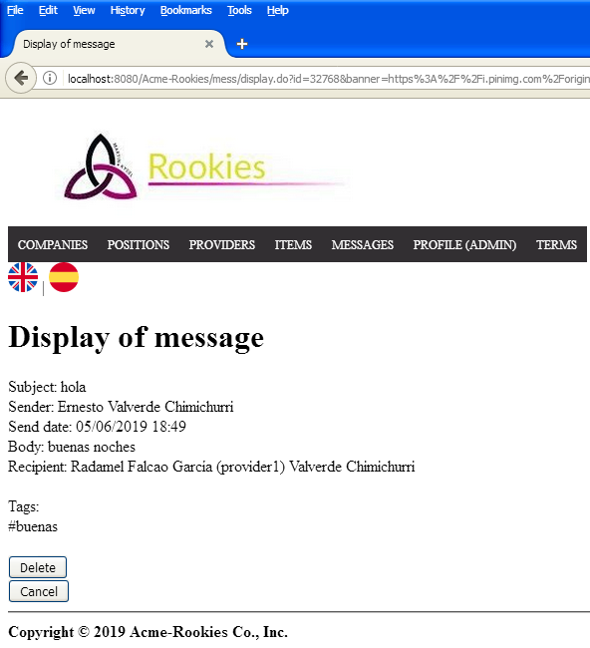

Tests

|  |  |
| --- | --- |
| **Test 001** | |
| **Description** | A user can send a message to another user. We fill the recipient correctly, the tags. The subject and the body must not be blank. |
| **Expected** | The system must return to a view where shows the display of the message. |
| **Outcome** | El mensaje se envía y se muestra. |
| **Notes** |  |

|  |  |
| --- | --- |
| **Test 002** | |
| **Description** | A user tries to sent a mess without fill the inputs. |
| **Expected** |  |
| **Outcome** | Se muestran los errores esperados. |
| **Notes** |  |

|  |  |
| --- | --- |
| **Test 003** | |
| **Description** | A non-authenticated user tries to enter by URL to the message creation sending. |
| **Expected** | The system must return him/her to the view of login into the system. |
| **Outcome** | El sistema redirige al login. |
| **Notes** |  |

# Use case UC14 Send a broadcast message.

Description

An administrator can send a message to all actors in the system.

Access

Login > Main menu > Messages > Mess sent > Create a message > Send a notification



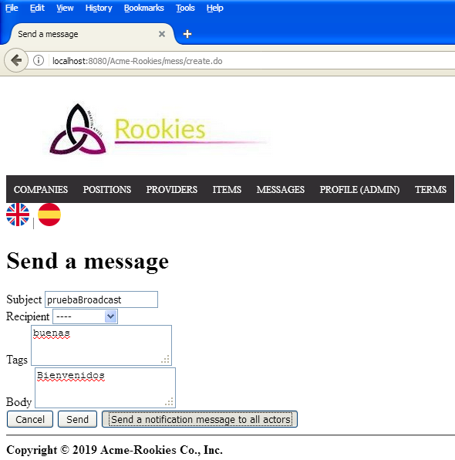

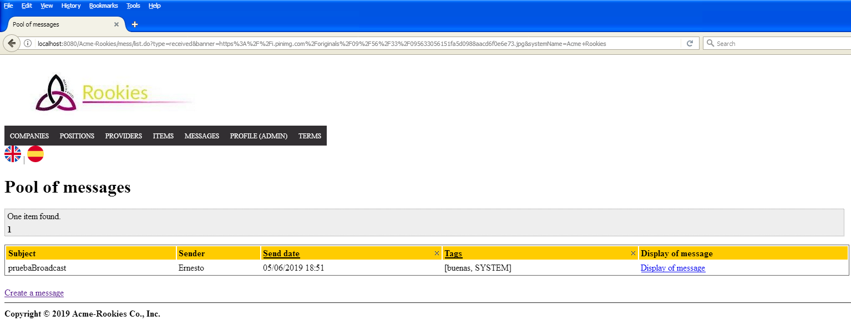

Tests

|  |  |
| --- | --- |
| **Test 001** | |
| **Description** | A user can send a message to every actor. We fill the tags. The subject and the body must not be blank. |
| **Expected** | The system must return to a view where shows the display of the message. |
| **Outcome** | Logueado como admin, el sistema permite enviar un mensaje a todos los usuarios del mismo. |
| **Notes** |  |

|  |  |
| --- | --- |
| **Test 002** | |
| **Description** | A user tries to sent a broadcast mess without fill the inputs. |
| **Expected** |  |
| **Outcome** | El sistema muestra los errores esperados. |
| **Notes** |  |

|  |  |
| --- | --- |
| **Test 003** | |
| **Description** | A non-authenticated user tries to enter by URL to the message creation sending. |
| **Expected** | The system must return him/her to the view of login into the system. |
| **Outcome** | El sistema redirige al login. |
| **Notes** |  |

# Use case UC15 Search by tags.

Description

A user can list messages searching by tags.

Access

Login > Main menu > Messages > Search by tags > Submit

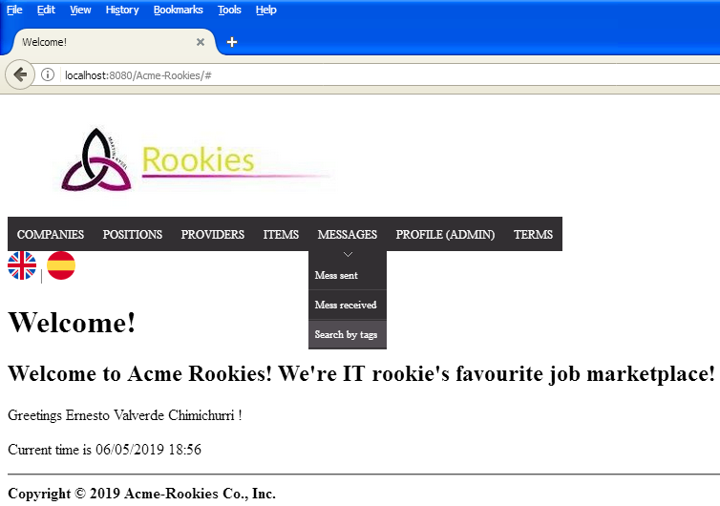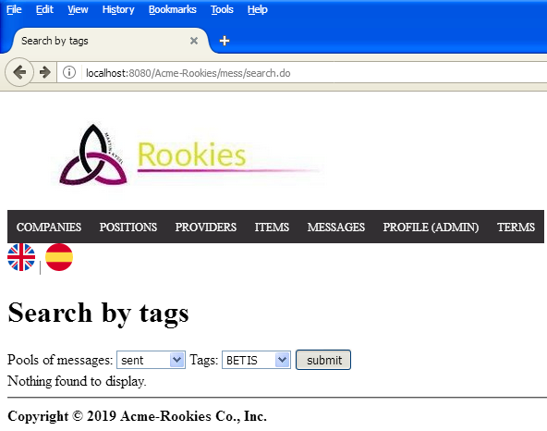

Tests

|  |  |
| --- | --- |
| **Test 001** | |
| **Description** | A user can search a message selecting the pool of messages and a tag. Using pool: ‘Sent’ and Tag: ‘BETIS’ |
| **Expected** | The system must return to a view where shows a list with a message which is included in that pool and has that tag. |
| **Outcome** | Se listan los mensajes que tienen la “tag” por la que hemos filtrado. |
| **Notes** |  |

# Use case UC16 Display a message.

Description

A user can display his/her messages.

Access

Login > Main menu > Messages > Search by tags > Submit

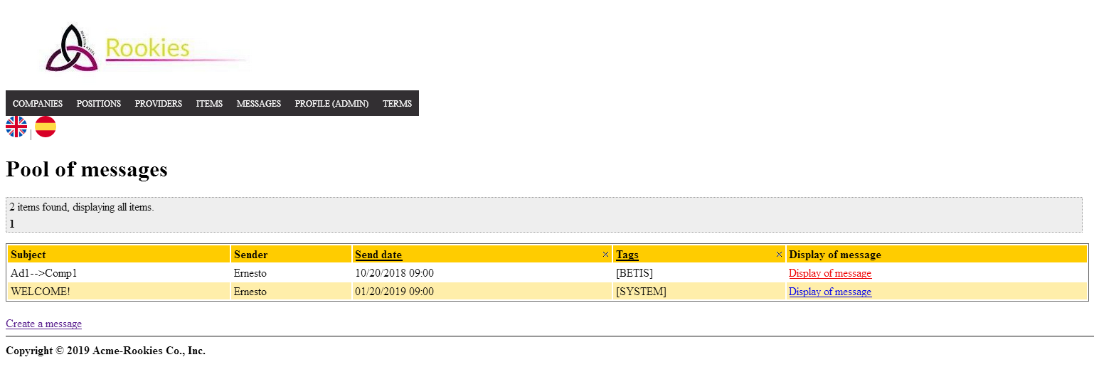

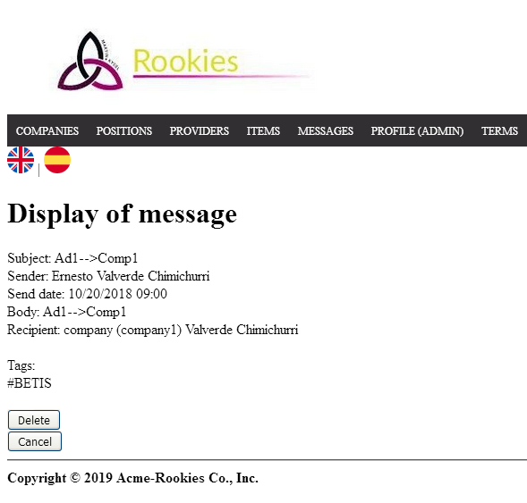

Tests

|  |  |
| --- | --- |
| **Test 001** | |
| **Description** | A user can display a message selecting a message from the list of messages. |
| **Expected** | The system must return to a view where shows the display of the message with the fields: ‘Subject, sender, send date, body, recipient and tags’. |
| **Outcome** | Se muestra la vista del mensaje, pero no incluye los parámetros “Subject” y “Body" |
| **Notes** |  |

|  |  |
| --- | --- |
| **Test 002** | |
| **Description** | A user tries to access to a message with an Id that doesn’t exist. |
| **Expected** | The system must return the user to the index page. |
| **Outcome** | El sistema redirige a la página de inicio. |
| **Notes** |  |

# Use case UC17 Delete a message.

Description

A user can delete his/her messages.

Access

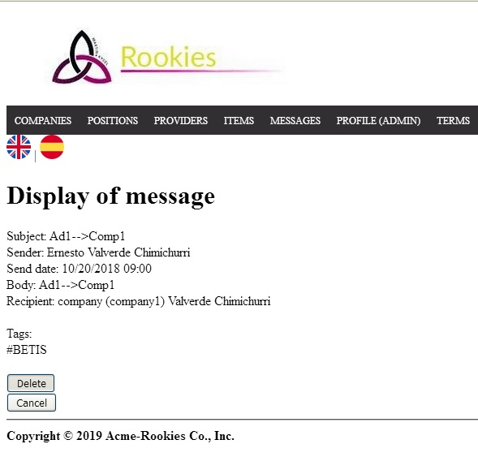

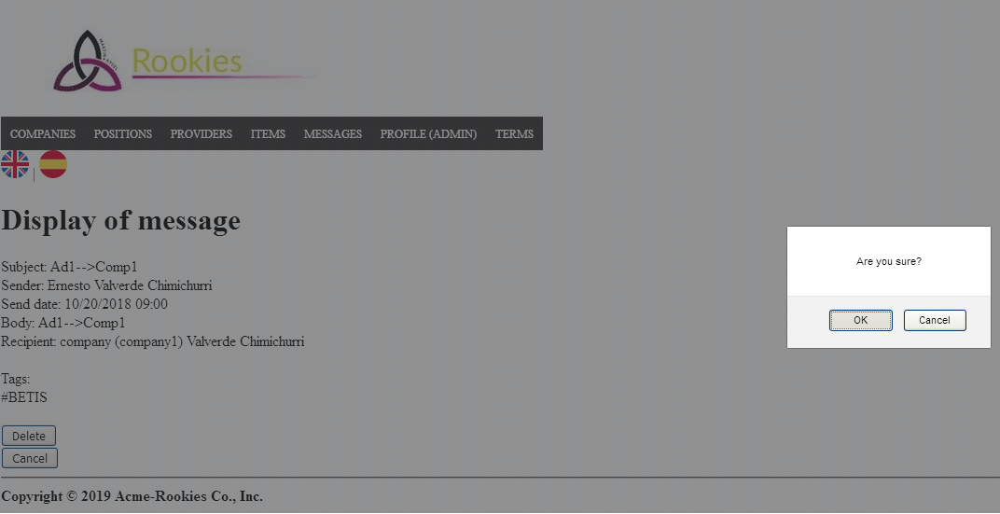

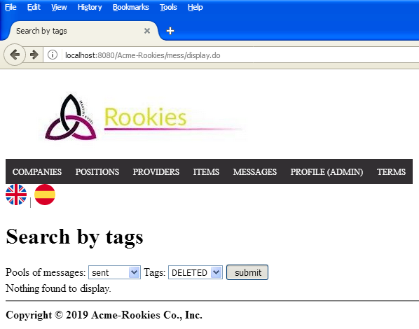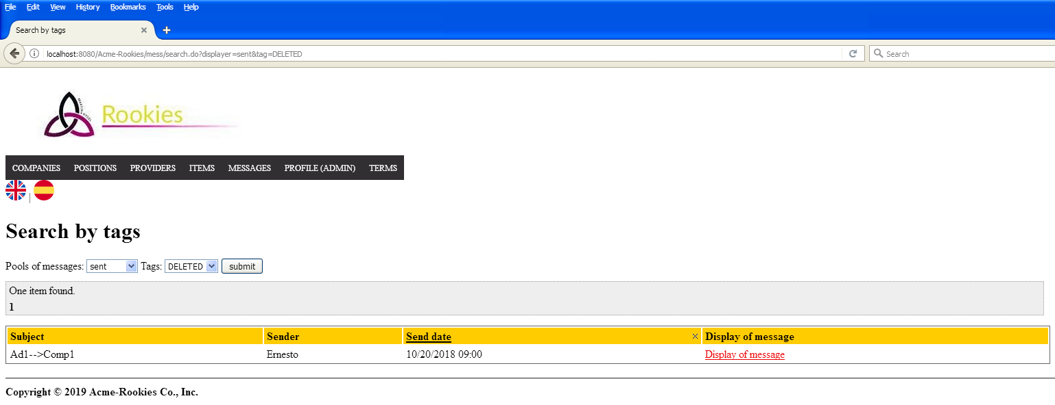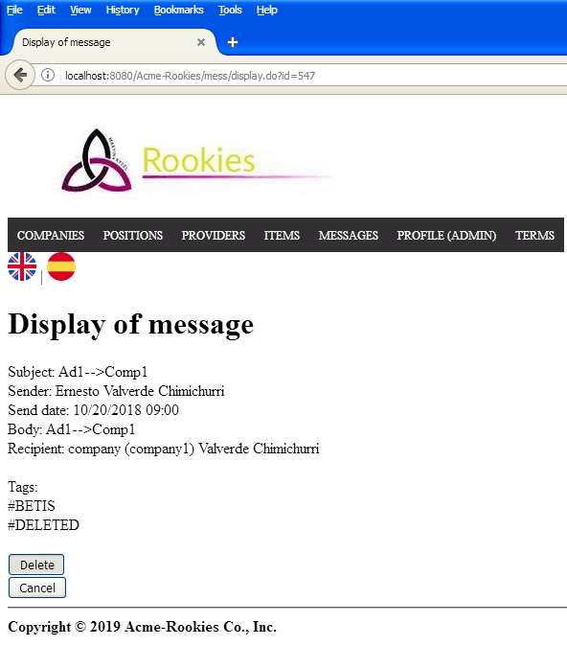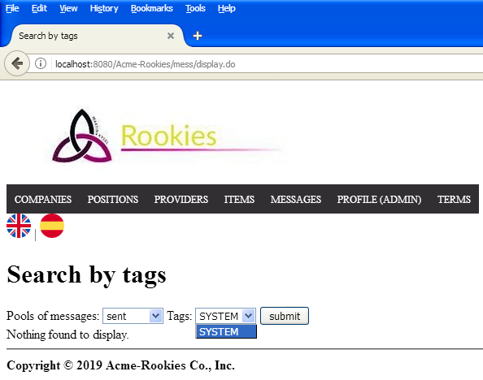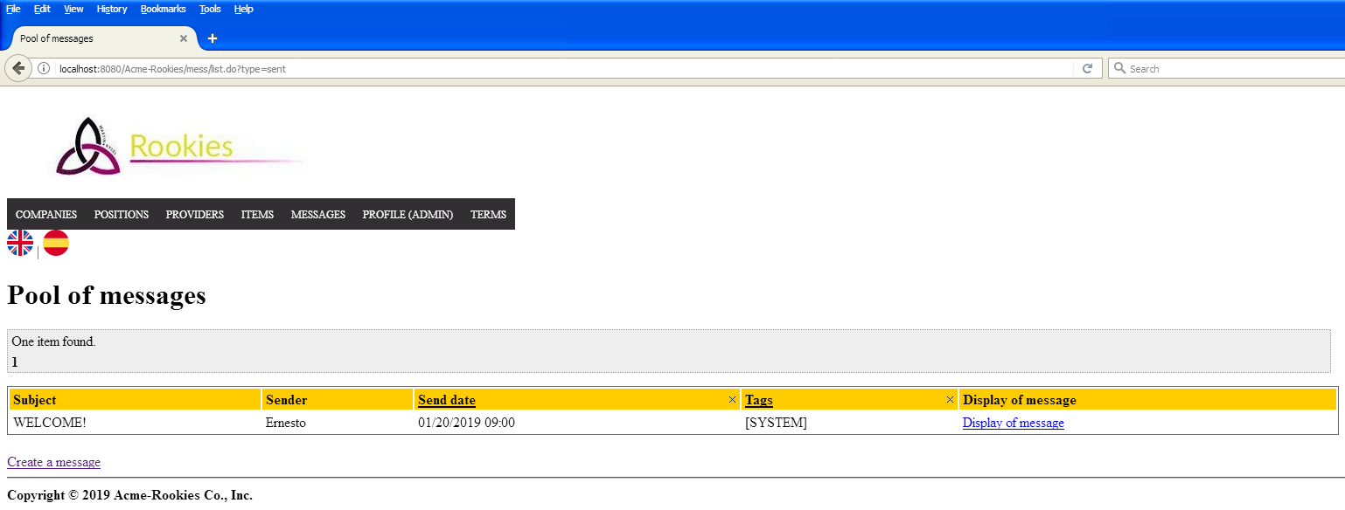

Tests

|  |  |
| --- | --- |
| **Test 001** | |
| **Description** | A user can delete a message if he/she pushes the button “Delete” on the display. |
| **Expected** | The system must return to the search view to look for the messages. If it’s the first time, the message will get a tag “DELETED”. If the user pushes the button “Delete” again, the message will be removed from the system. |
| **Outcome** | El sistema se comporta como se espera. |
| **Notes** |  |

# Use case UC18 List sponsorships.

Before testing

We will use provider1/provider1 to log into the system. We will use this user account to make testing from UC18-UC22

Description

An authenticated provider can list his/her sponsorships.

Access

Login > Main menu > Sponsorships

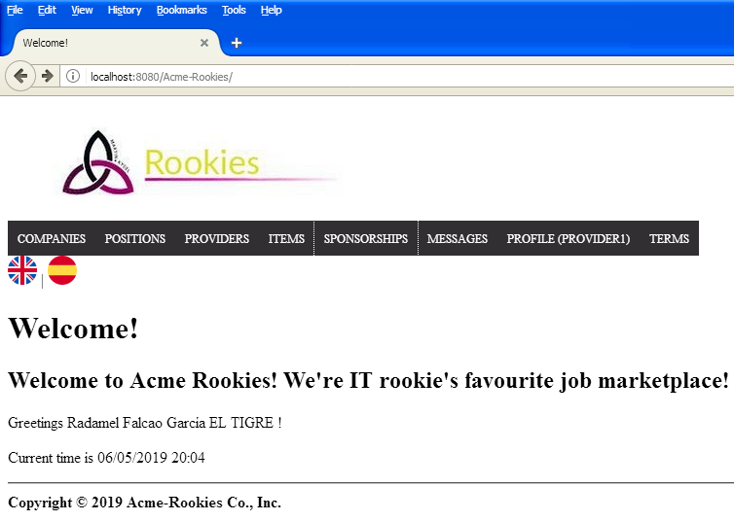

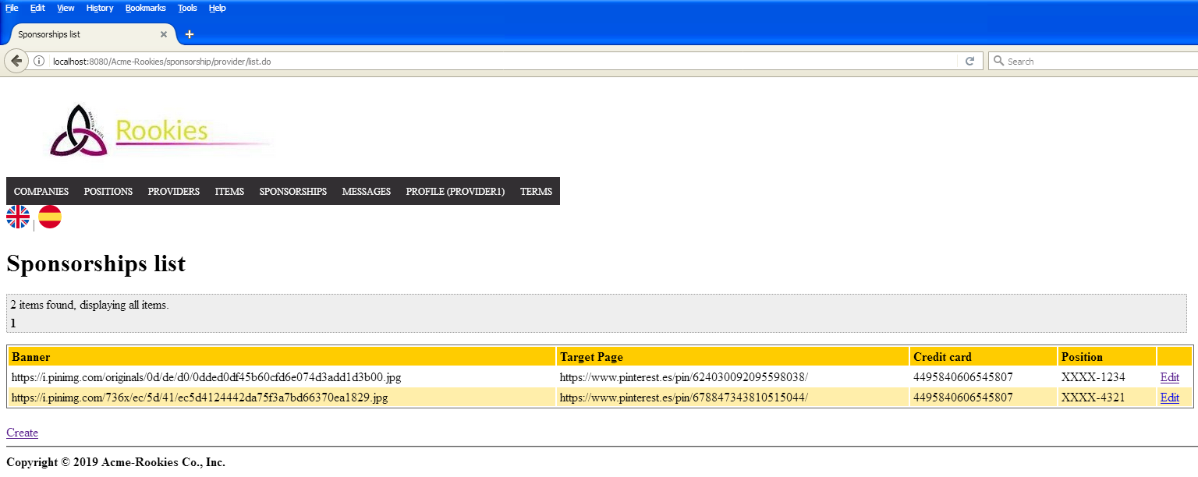

Tests

|  |  |
| --- | --- |
| **Test 001** | |
| **Description** | A user can list his/her sponsorships. |
| **Expected** | The system must return to a view where shows a list of sponsorships owned by the logged actor. |
| **Outcome** | El sistema muestra una lista de los sponsorship. |
| **Notes** |  |

# Use case UC19 Create a sponsorship.

Before testing

We will use admin/admin to log into the system. We will use this user account to make testing from UC19-UC21

Description

An authenticated provider can create a sponsorship.

Access

Login > Main menu > Sponsorships > Create > Save 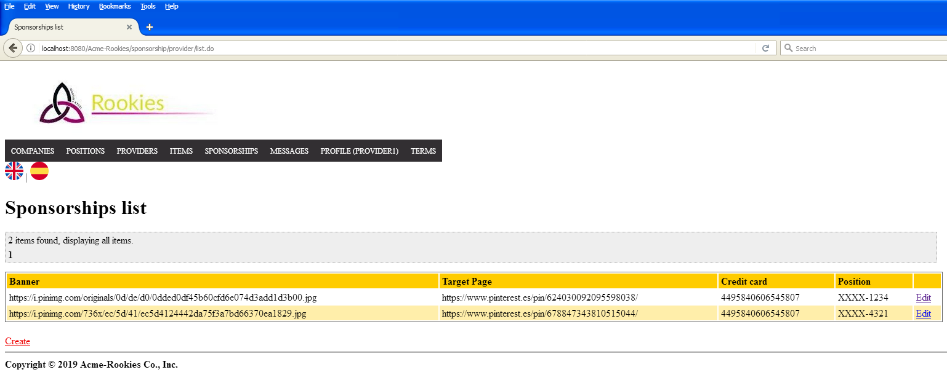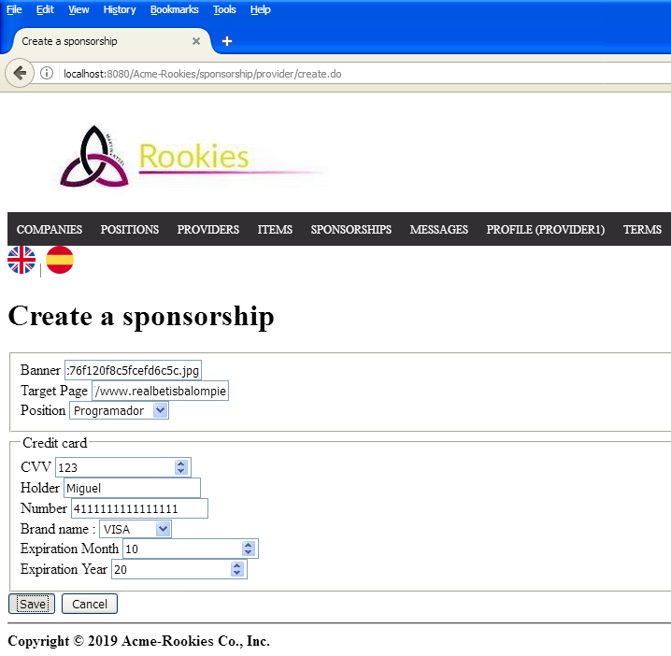

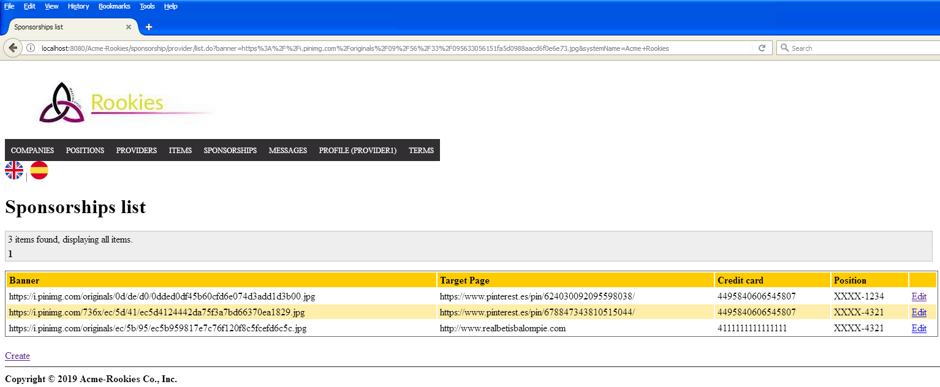

Tests

|  |  |
| --- | --- |
| **Test 001** | |
| **Description** | A user can create a sponsorship. We fill the banner image and the target page fields with an URL select a position correctly and introduce a valid credit card. |
| **Expected** | The system must return to a view where shows a list of sponsorships owned by the logged actor, including the new sponsorship created. |
| **Outcome** | Funciona correctamente. |
| **Notes** |  |

# Use case UC20 Edit a sponsorship.

Description

An authenticated provider can edit his/her sponsorships.

Access

*Login > Main menu > Sponsorships > Edit > Save*





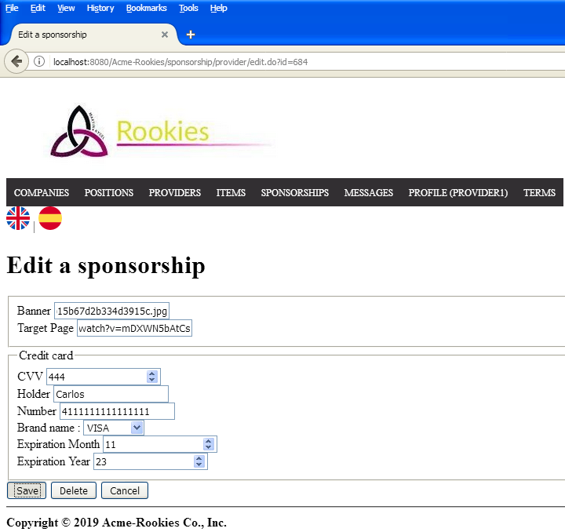

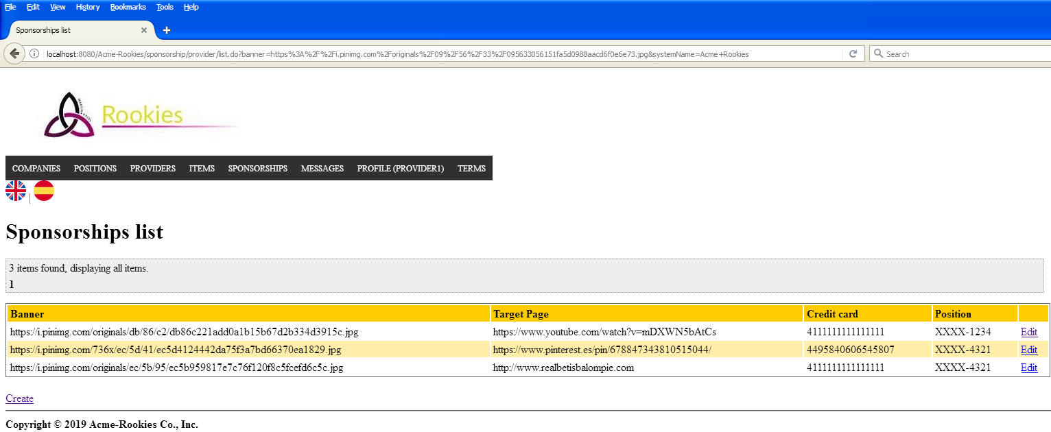

Tests

|  |  |
| --- | --- |
| **Test 001** | |
| **Description** | A user can edit a sponsorship. We fill the banner image and the target page fields with an URL and introduce a new valid credit card. |
| **Expected** | The system must return to a view where shows a list of sponsorships owned by the logged actor, including the sponsorship modified. |
| **Outcome** | Funciona correctamente. |
| **Notes** |  |

|  |  |
| --- | --- |
| **Test 002** | |
| **Description** | A user tries to edit a sponsorship which is owned by other provider changing the id in the URL. |
| **Expected** | The system must return the user to the index page. |
| **Outcome** | El sistema redirige a la vista de login. |
| **Notes** |  |

# Use case UC21 Delete a sponsorship.

Description

An authenticated provider can delete his/her sponsorship .

Access

Login > Main menu > Sponsorships > Edit > Delete 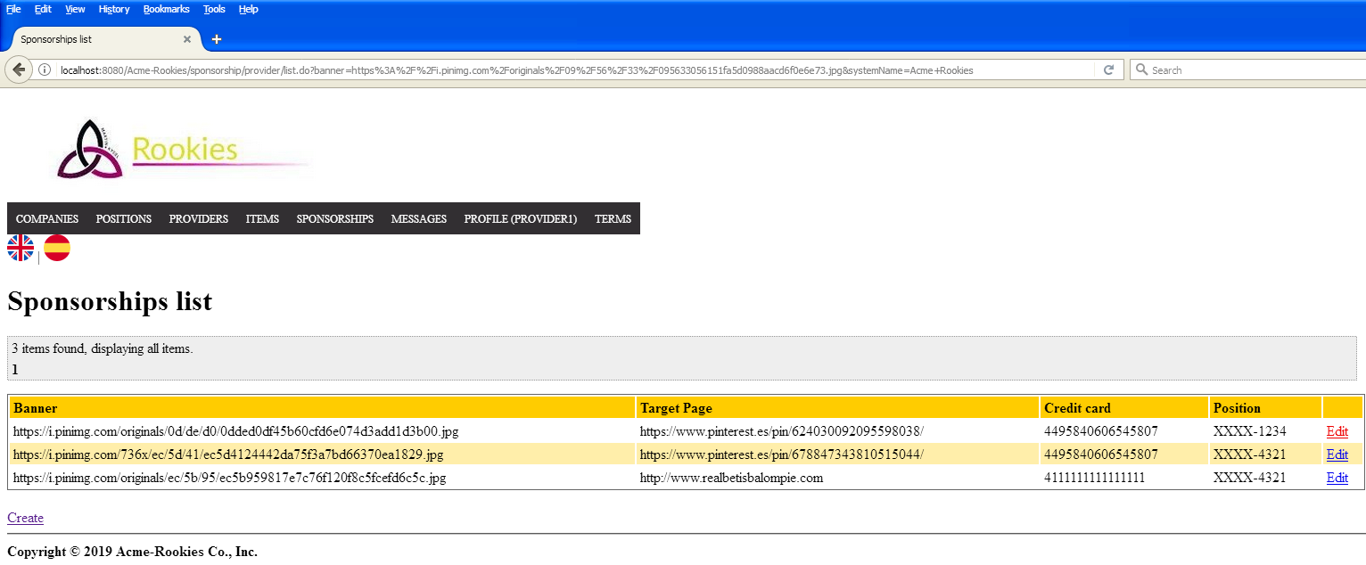

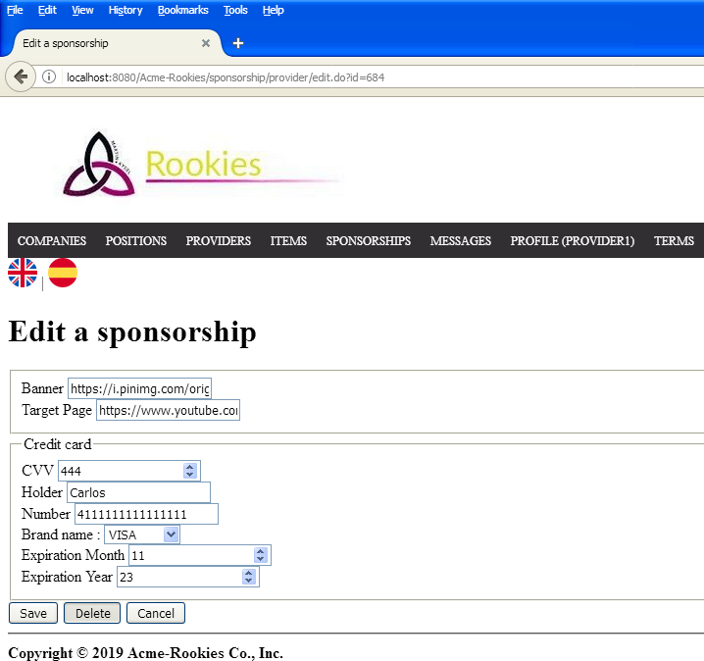

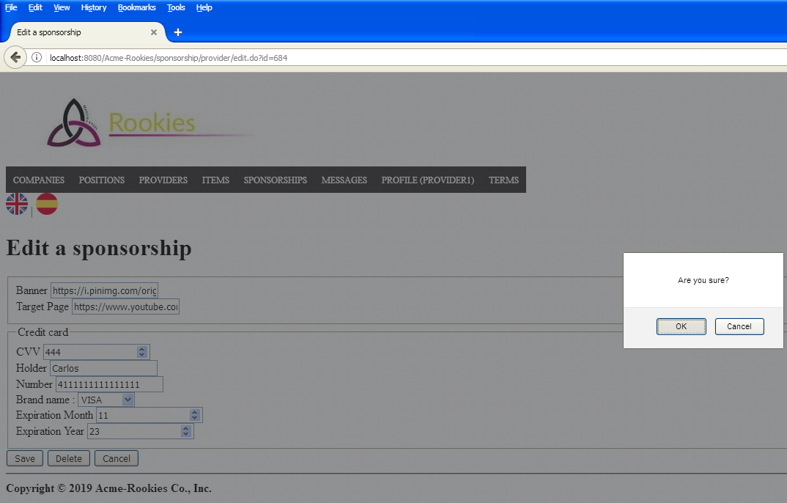

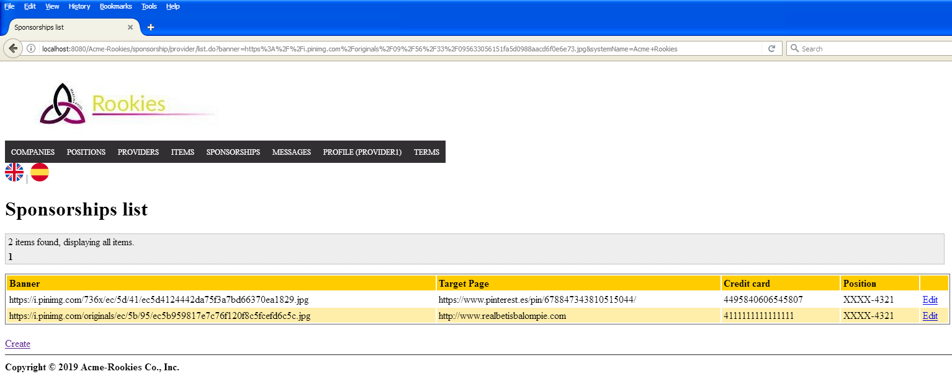

Tests

|  |  |
| --- | --- |
| **Test 001** | |
| **Description** | A user can delete a sponsorship if he/she pushes the button “Delete” on the edit. |
| **Expected** | The system must return to a view where shows a list of sponsorships owned by the logged actor, without the sponsorship deleted. |
| **Outcome** | El sistema elimina el sponsorship y muestra la lista sin este. |
| **Notes** |  |

# Use case UC22 List items.

Description

An unauthenticated actor can list items.

Access

Login > Main menu > Items

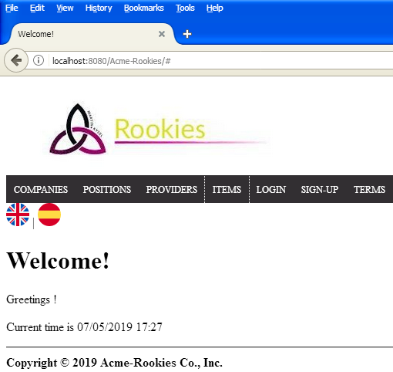

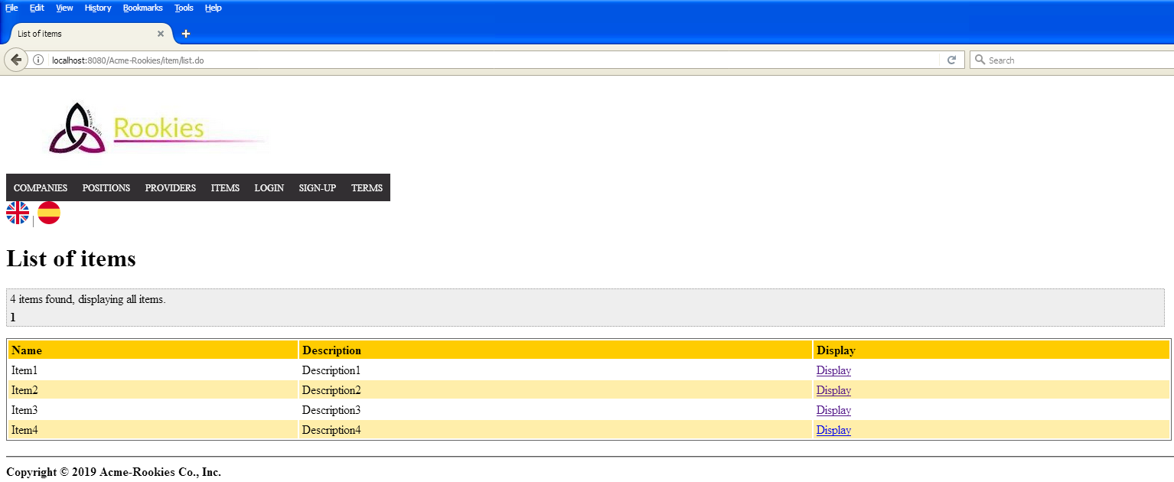

Tests

|  |  |
| --- | --- |
| **Test 001** | |
| **Description** | A user can list items. |
| **Expected** | The system must return to a view where shows a list of items. |
| **Outcome** | El sistema muestra la lista de items. |
| **Notes** |  |

# Use case UC23 Display an item.

Description

A user can display an item.

Access

Login > Main menu > Items > Display



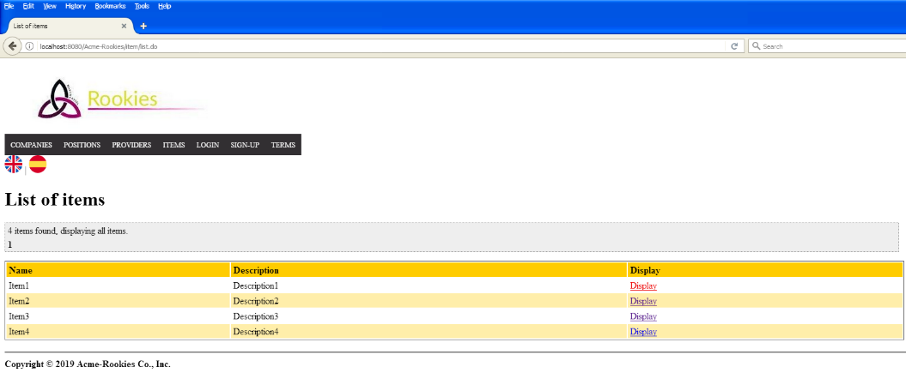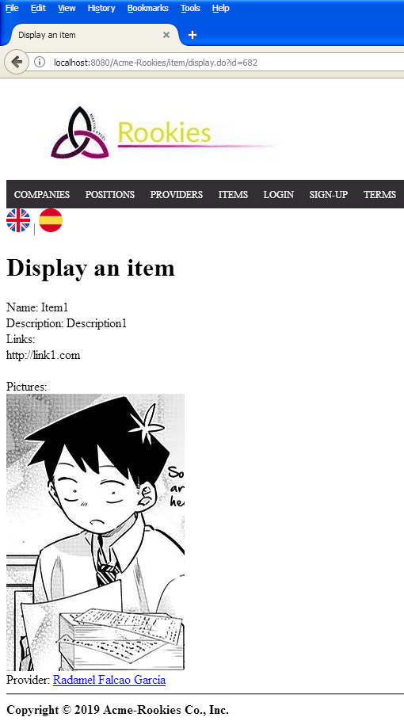

Tests

|  |  |
| --- | --- |
| **Test 001** | |
| **Description** | A user can display an item if he/she clicks on “display” of an item from the list of items. |
| **Expected** | The system must return to a view where shows the display of the message with the fields: ‘Name, description, links, pictures and his/her provider’. |
| **Outcome** | El sistema muestra los datos esperados. |
| **Notes** |  |

|  |  |
| --- | --- |
| **Test 002** | |
| **Description** | A user tries to access to an item with an Id that doesn’t exist. |
| **Expected** | The system must return the user to the index page. |
| **Outcome** | El sistema redirige a la página de inicio. |
| **Notes** |  |

# Use case UC24 Create an item.

Before testing

We will use admin/admin to log into the system. We will use this user account to make testing from UC24-UC26

Description

An authenticated provider can create a sponsorship.

Access

Login > Main menu > My items > Create > Save 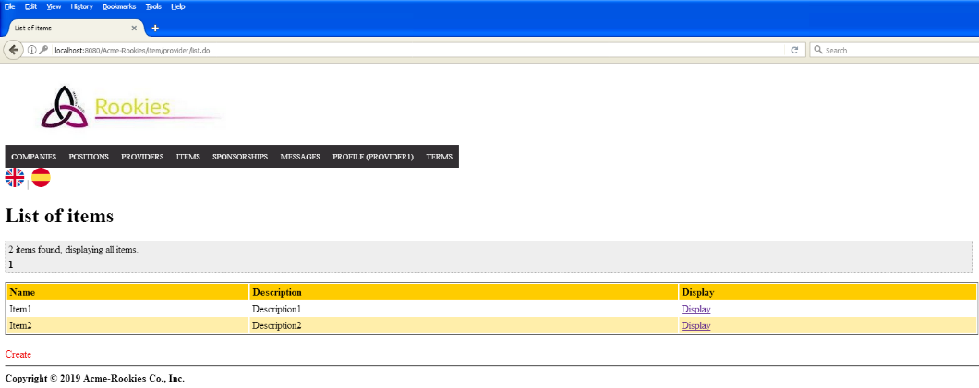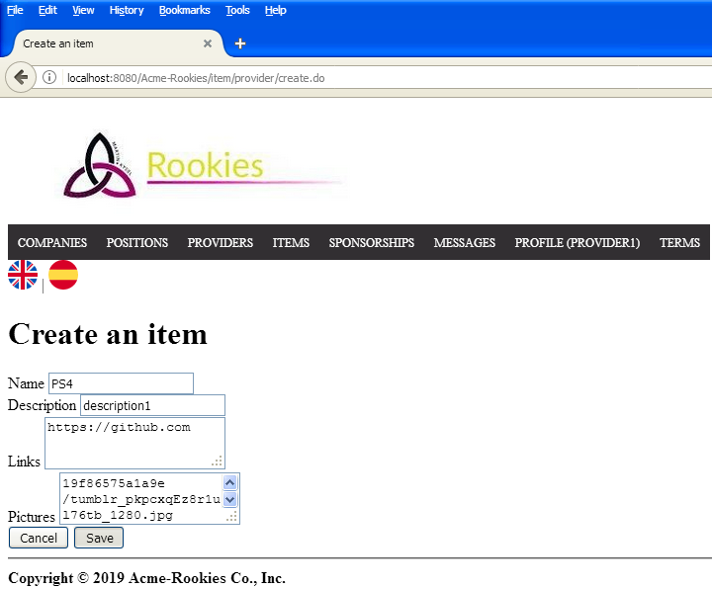

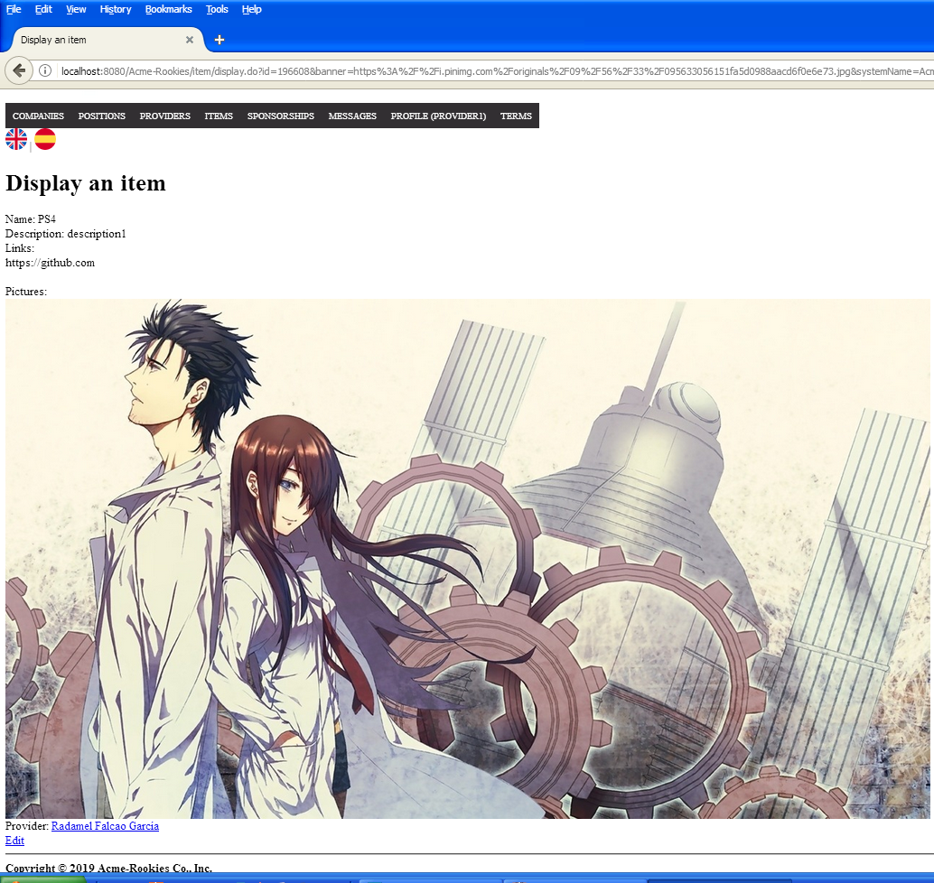

Tests

|  |  |
| --- | --- |
| **Test 001** | |
| **Description** | A user can create an item. We fill inputs: Name, Description, links and pictures. |
| **Expected** | The system must return to a view where shows a display of the item. |
| **Outcome** | El sistema crea el item y redirige a una vista con sus datos. |
| **Notes** |  |

# Use case UC25 Edit an item.

Description

An authenticated provider can edit his/her item.

Access

Login > Main menu > My items > Display > Edit > Save 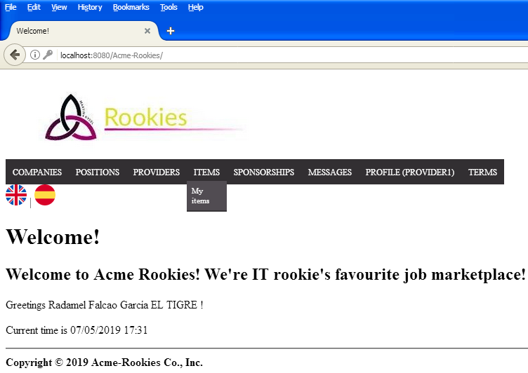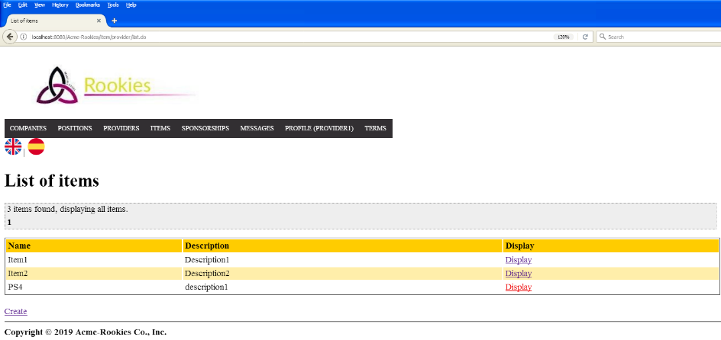

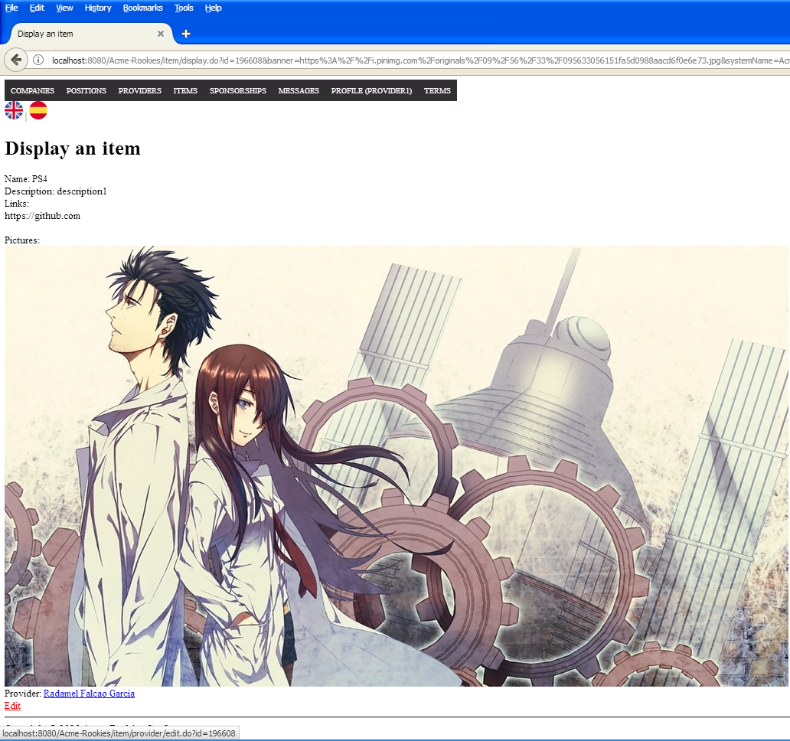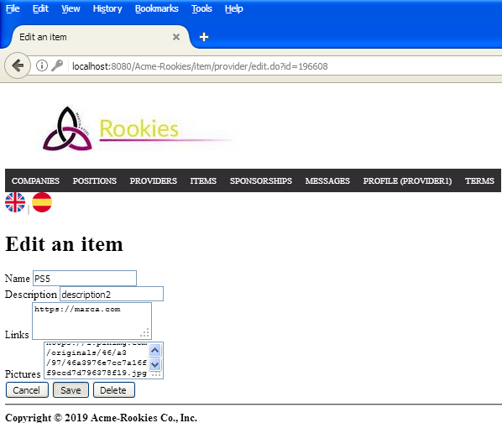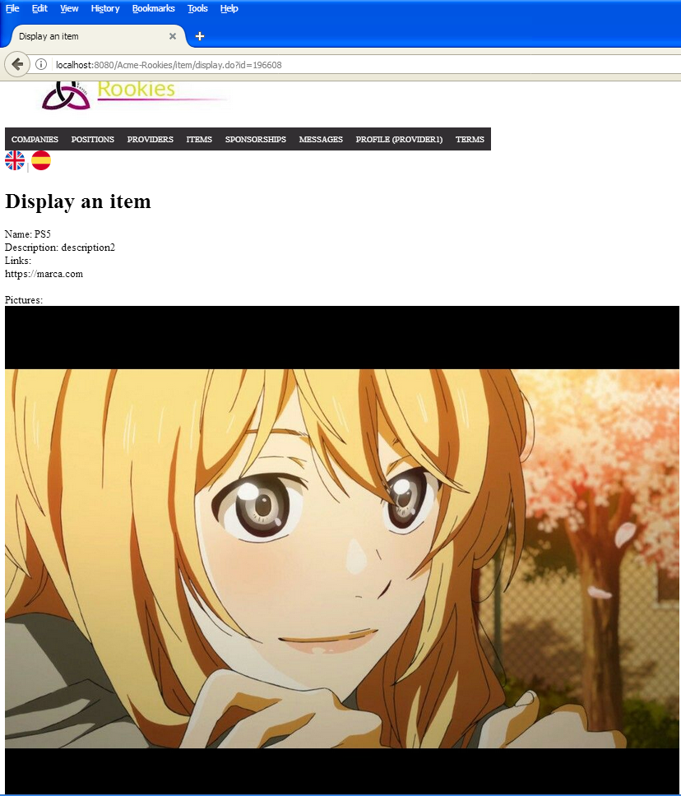

Tests

|  |  |
| --- | --- |
| **Test 001** | |
| **Description** | A user can edit an item. We fill inputs: Name, Description, links and pictures. |
| **Expected** | The system must return to a view where shows a display of the item. |
| **Outcome** | El sistema ha editado el item y redirige a una vista con sus nuevos datos. |
| **Notes** |  |

|  |  |
| --- | --- |
| **Test 002** | |
| **Description** | A user tries to edit an item which is owned by other provider changing the id in the URL. |
| **Expected** | The system must return the user to the index page. |
| **Outcome** | El sistema redirige a la página de inicio. |
| **Notes** |  |

# Use case UC26 Delete an item.

Description

An authenticated provider can delete his/her items.

Access

Login > Main menu > My items > Display > Edit > Delete 



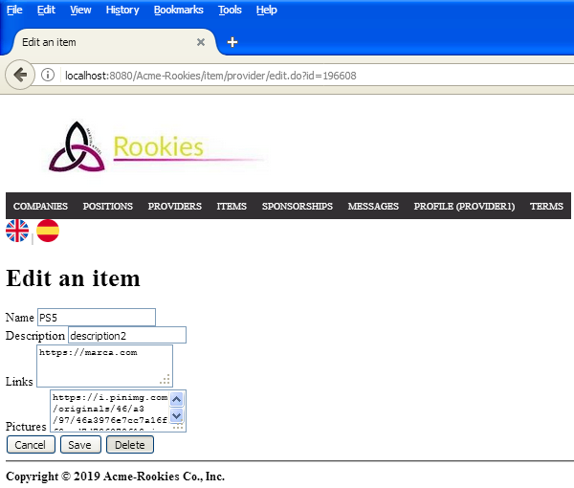

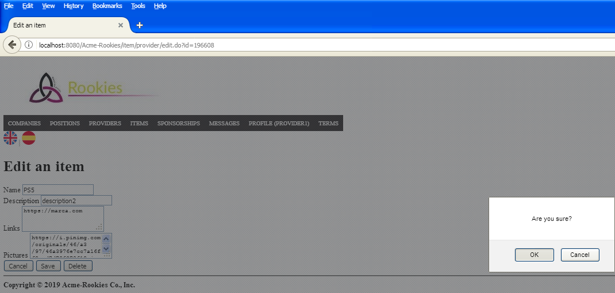

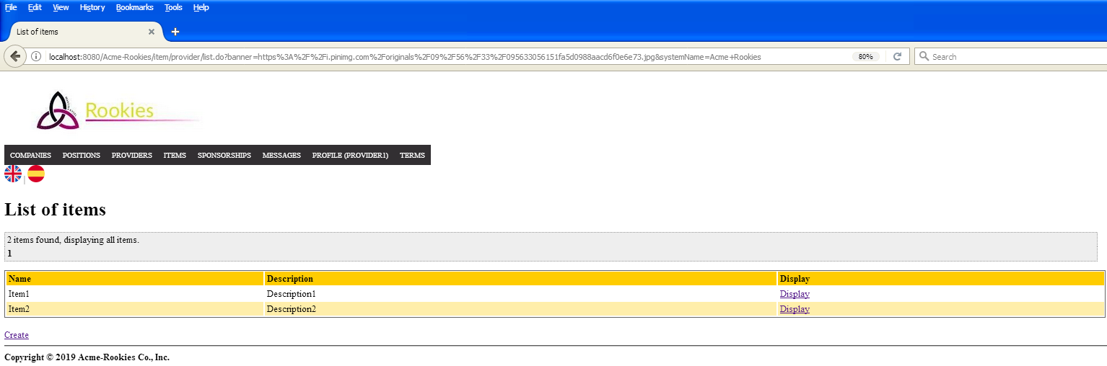

Tests

|  |  |
| --- | --- |
| **Test 001** | |
| **Description** | A user can delete a items if he/she pushes the button “Delete” on the edit. |
| **Expected** | The system must return to a view where shows a list of items owned by the logged actor, without the items deleted. |
| **Outcome** | El sistema elimina el item y muestra la lista sin este. |
| **Notes** |  |

# Use case UC27 List problems.

Description

An authenticated company can list his problems.

Access

Login > Main menu > Problems

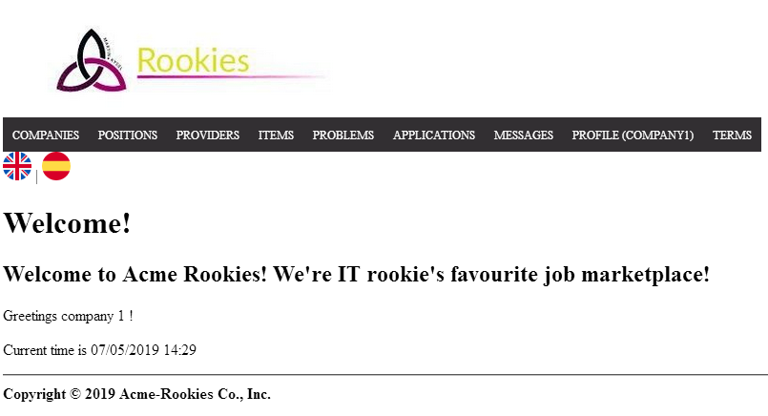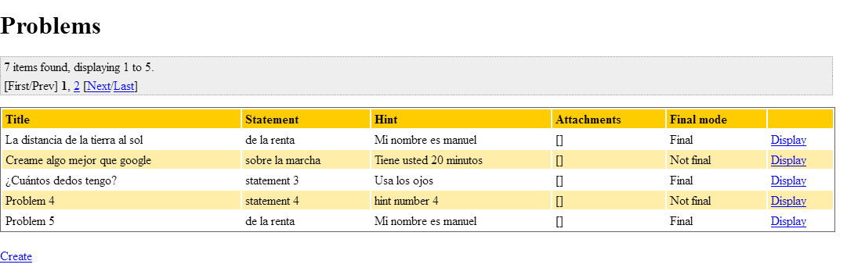

Tests

|  |  |
| --- | --- |
| **Test 001** | |
| **Description** | A company can list his problems. |
| **Expected** | The system must return to a view where shows a list of problems owned by the logged company |
| **Outcome** | El sistema lista los problemas. |
| **Notes** |  |

|  |  |
| --- | --- |
| **Test 002** | |
| **Description** | A non company or a non authenticated actor tries to access to the list of problems by url |
| **Expected** | The system must return the user to the index page. |
| **Outcome** | El sistema redirige a la vista de login. |
| **Notes** |  |

# Use case UC29 Display problems.

Description

An authenticated company can display his problems.

Access

Login > Main menu > Problems > Display





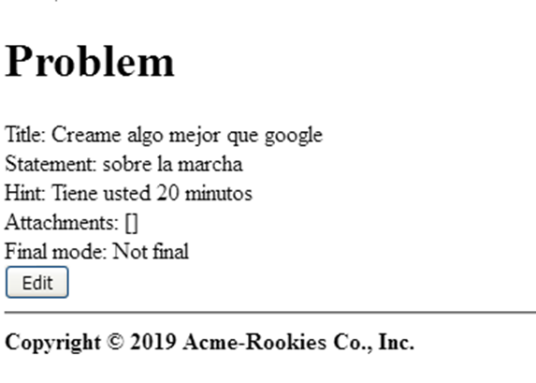

Tests

|  |  |
| --- | --- |
| **Test 001** | |
| **Description** | A company can display his problems. |
| **Expected** | The system must return to a view that shows the information of the problem selected. |
| **Outcome** | El sistema muestra los datos del problema. |
| **Notes** |  |

|  |  |
| --- | --- |
| **Test 002** | |
| **Description** | A company that doesn’t own the problem or a non authenticated actor tries to access to the display of problem by url |
| **Expected** | The system must return the user to the index page. |
| **Outcome** | El sistema redirige a la página de login. |
| **Notes** |  |

# Use case UC30 Create a problem.

Description

An authenticated company can create a problem.

Access

Login > Main menu > Problems > Create > Save





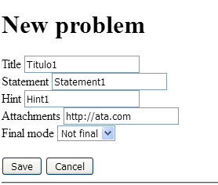

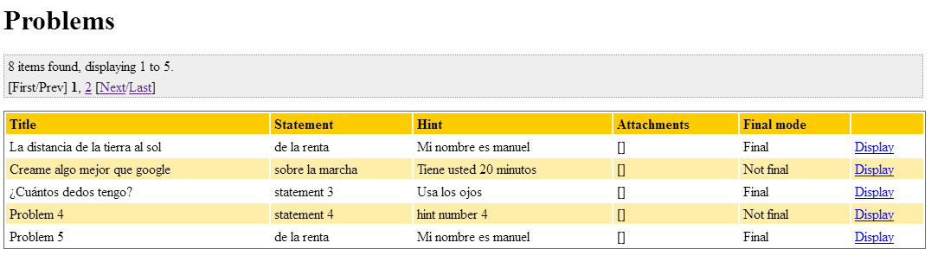Tests

|  |  |
| --- | --- |
| **Test 001** | |
| **Description** | A company can create a problem. We fill the tittle, statement, hint and attachments with valid data. |
| **Expected** | The system must return to a view where shows a list of problems owned by the logged company, including the new problem created. |
| **Outcome** | El sistema crea el problema y lista los problemas existentes, apareciendo el que acabamos de crear. |
| **Notes** |  |

|  |  |
| --- | --- |
| **Test 002** | |
| **Description** | Click on “Save” buttom without filling the form |
| **Expected** |  |
| **Outcome** | El sistema muestra los errores esperados. |
| **Notes** |  |

|  |  |
| --- | --- |
| **Test 003** | |
| **Description** | A company tries to fill the form with non valid data |
| **Expected** |  |
| **Outcome** | El sistema muestra los errores esperados. |
| **Notes** |  |

|  |  |
| --- | --- |
| **Test 004** | |
| **Description** | Click on “cancel” button. |
| **Expected** | The system must return to the list of problems |
| **Outcome** | El sistema redirige a la lista de problemas. |
| **Notes** |  |

|  |  |
| --- | --- |
| **Test 005** | |
| **Description** | A non company or a non authenticated actor tries to access to the create form by url |
| **Expected** | The system must return the user to the index page. |
| **Outcome** | El sistema redirige a la página de login. |
| **Notes** |  |

# Use case UC31 Edit a problem.

Description

An authenticated company can edit his problems as long as they are not in finalMode.

Access

Login > Main menu > Problems > Display > Edit > Save

 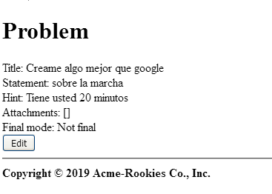

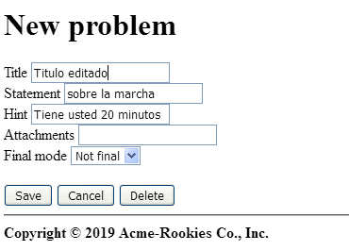

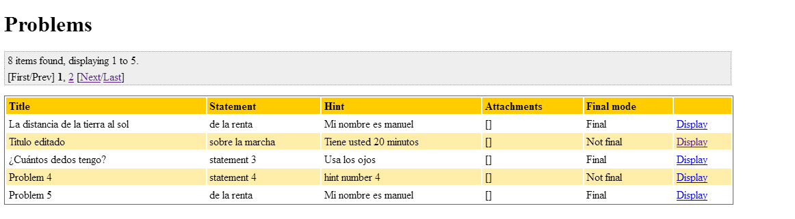Tests

|  |  |
| --- | --- |
| **Test 001** | |
| **Description** | A company can edit his problems if they are not in final mode. We edit the tittle, statement, hint and attachments with valid data. |
| **Expected** | The system must return to a view where shows a list of problems owned by the logged company, including the new problem edited. |
| **Outcome** | El sistema edita el problema y muestra la lista de problemas. |
| **Notes** |  |

|  |  |
| --- | --- |
| **Test 002** | |
| **Description** | Trying to edit the problem with all the gaps blank |
| **Expected** |  |
| **Outcome** | El sistema muestra los errores esperados |
| **Notes** |  |

|  |  |
| --- | --- |
| **Test 003** | |
| **Description** | Trying to edit the problem with non-valid data |
| **Expected** |  |
| **Outcome** | El sistema muestra los errores esperados |
| **Notes** |  |

|  |  |
| --- | --- |
| **Test 004** | |
| **Description** | Click on “cancel” button. |
| **Expected** | The system must return to the list of problems |
| **Outcome** | El sistema redirige a la lista de problemas. |
| **Notes** |  |

|  |  |
| --- | --- |
| **Test 005** | |
| **Description** | Trying to access to the edit form of a final Mode problem by URL |
| **Expected** | The system must return the user to the index page. |
| **Outcome** | El sistema redirige a la página de inicio. |
| **Notes** |  |

|  |  |
| --- | --- |
| **Test 006** | |
| **Description** | A company that does not own a problem or a non-authenticated actor tries to access to the edit form by URL |
| **Expected** | The system must return the user to the index page. |
| **Outcome** | El sistema redirige a la página de login. |
| **Notes** |  |

# Use case UC32 Delete a problem.

Description

An authenticated company can delete his problems as long as they are not in final Mode.

Access

Login > Main menu > Problems > Display > Edit > Delete







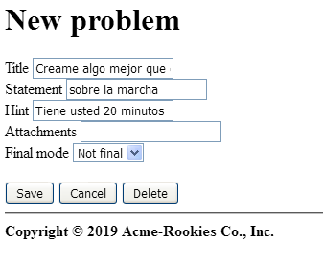

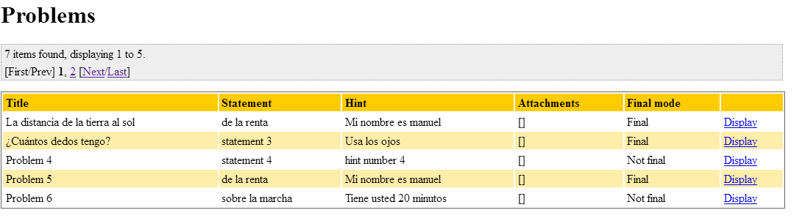Tests

|  |  |
| --- | --- |
| **Test 001** | |
| **Description** | A company can delete his problems if they are not in final mode. |
| **Expected** | The system must return to a view where shows a list of problems owned by the logged company, without the deleted problem. |
| **Outcome** | El sistema elimina el problema y redirige a la lista de problemas donde no aparece el eliminado. |
| **Notes** |  |

# Use case UC33 List social profile.

Description

An authenticated actor can list his social profiles.

Access

Login > Main menu > Profile > Social Profiles

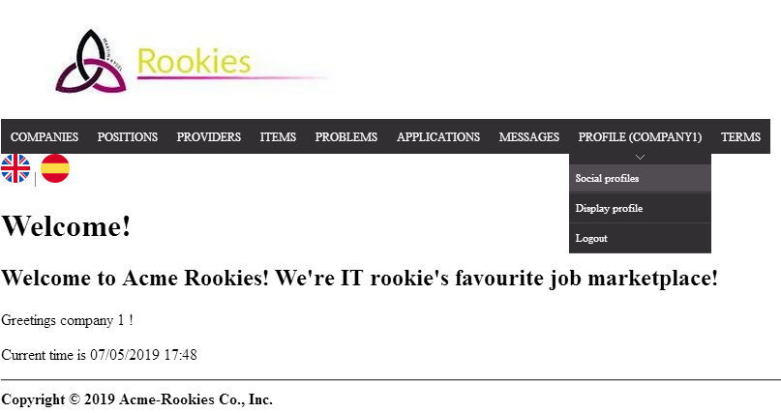

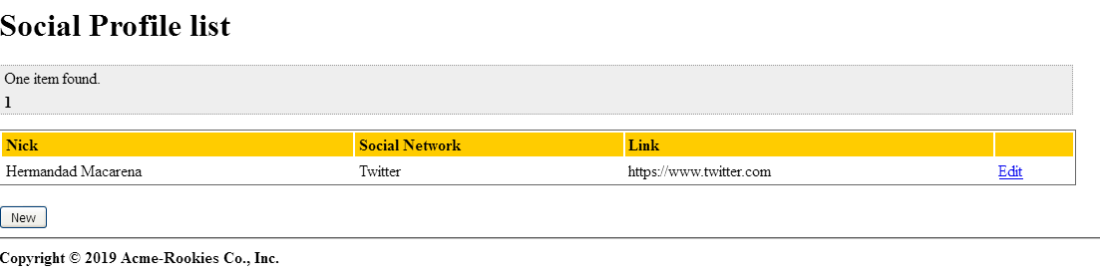

Tests

|  |  |
| --- | --- |
| **Test 001** | |
| **Description** | An actor can list his social Profile. |
| **Expected** | The system must return to a view where shows a list of social profiles owned by the logged actor |
| **Outcome** | El sistema no muestra el parámetro “Nick” en el listado. |
| **Notes** |  |

|  |  |
| --- | --- |
| **Test 002** | |
| **Description** | A non-authenticated actor tries to access to the list of social profiles by URL |
| **Expected** | The system must return the user to the index page. |
| **Outcome** | El sistema redirige a la página de login. |
| **Notes** |  |

# Use case UC34 Create a social profile.

Description

An authenticated actor can create a social profile.

Access

Login > Main menu > Profile > Social profiles > New



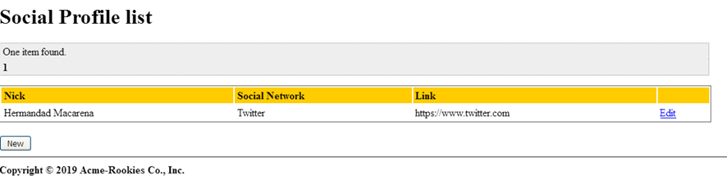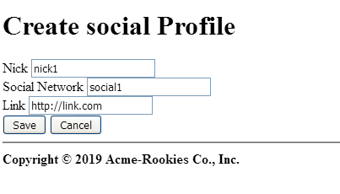

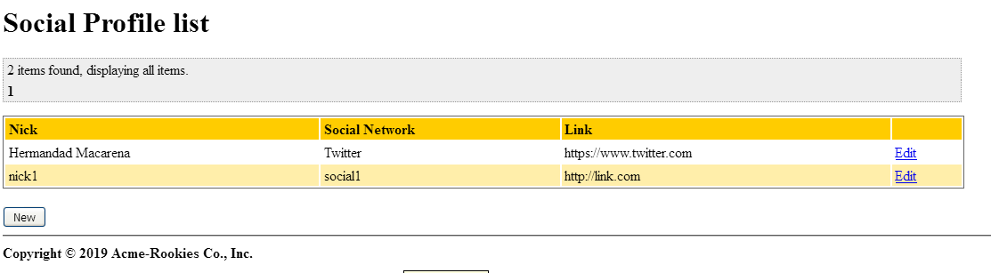Tests

|  |  |
| --- | --- |
| **Test 001** | |
| **Description** | An actor can create a social profile. We fill the form with valid data |
| **Expected** | The system must return to a view where shows a list of social profiles owned by the logged actor, including the new social profile created. |
| **Outcome** | El sistema crea el perfil y lo muestra en la lista de perfiles. |
| **Notes** |  |

|  |  |
| --- | --- |
| **Test 002** | |
| **Description** | Click on “Save” button without filling the form |
| **Expected** |  |
| **Outcome** | El sistema muestra los errores esperados. |
| **Notes** |  |

|  |  |
| --- | --- |
| **Test 003** | |
| **Description** | An actor tries to fill the form with non-valid data |
| **Expected** |  |
| **Outcome** | El sistema muestra los errores esperados. |
| **Notes** |  |

|  |  |
| --- | --- |
| **Test 004** | |
| **Description** | Click on “cancel” button. |
| **Expected** | The system must return to the list of problems |
| **Outcome** | El sistema redirige a la lista de perfiles. |
| **Notes** |  |

|  |  |
| --- | --- |
| **Test 005** | |
| **Description** | A non-authenticated actor tries to access to the create form by URL |
| **Expected** | The system must return the user to the index page. |
| **Outcome** | El sistema redirige a la página de login. |
| **Notes** |  |

# Use case UC35 Edit a social Profile.

Description

An authenticated actor can edit his social profiles.

Access

Login > Main menu > Profile > Social profiles > Edit > Save





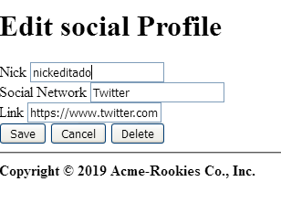

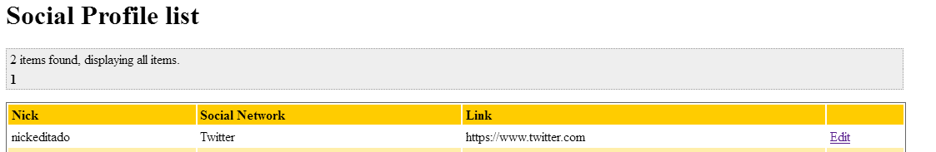

Tests

|  |  |
| --- | --- |
| **Test 001** | |
| **Description** | An actor can edit his social profile. We edit with valid data. |
| **Expected** | The system must return to a view where shows a list of social profiles owned by the logged actor, including the edited social profile. |
| **Outcome** | El sistema edita el perfil y lo muestra en la lista de perfiles. |
| **Notes** |  |

|  |  |
| --- | --- |
| **Test 002** | |
| **Description** | Click on “Save” button leaving all the gaps blank |
| **Expected** |  |
| **Outcome** | El sistema muestra los errores esperados. |
| **Notes** |  |

|  |  |
| --- | --- |
| **Test 003** | |
| **Description** | An actor tries to fill the form with non-valid data |
| **Expected** |  |
| **Outcome** | El sistema muestra los errores esperados. |
| **Notes** |  |

|  |  |
| --- | --- |
| **Test 004** | |
| **Description** | Click on “cancel” button. |
| **Expected** | The system must return to the list of problems |
| **Outcome** | El sistema redirige a la lista de perfiles. |
| **Notes** |  |

|  |  |
| --- | --- |
| **Test 005** | |
| **Description** | An actor that does not own a problem or a non-authenticated actor tries to access to the edit form by URL |
| **Expected** | The system must return the user to the index page. |
| **Outcome** | El sistema redirige a la página de login. |
| **Notes** |  |

# Use case UC36 Delete a social profile.

Description

An authenticated actor can delete his social profiles

Access

Login > Main menu > Profile > Social profiles > Edit > Delete



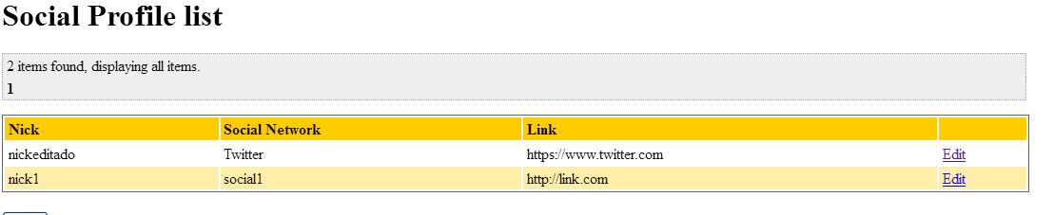



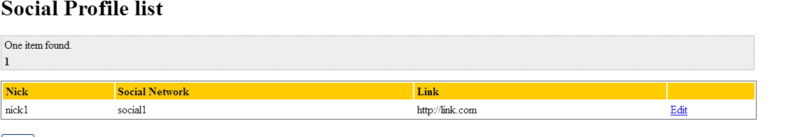

Tests

|  |  |
| --- | --- |
| **Test 001** | |
| **Description** | A company can delete his social profiles. |
| **Expected** | The system must return to a view where shows a list of social profiles owned by the logged actor, without the deleted one. |
| **Outcome** | El sistema elimina el perfil y muestra la lista de perfiles sin este. |
| **Notes** |  |

# Use case UC37 Display dashboard.

Description

An admin can display the dashboard

Access

Login > Main menu > Profile > Dashboard

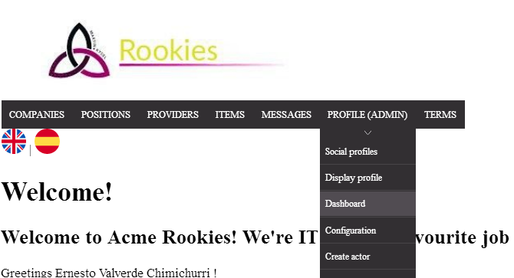

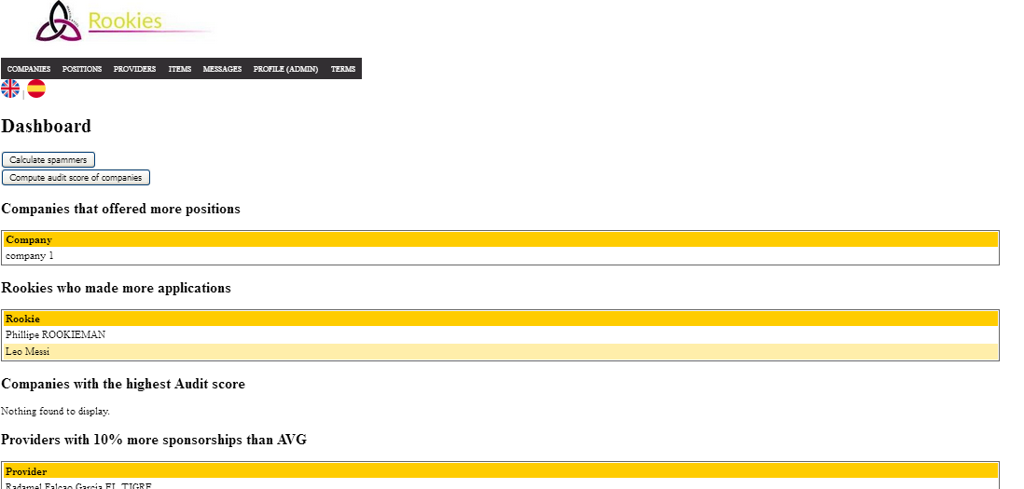

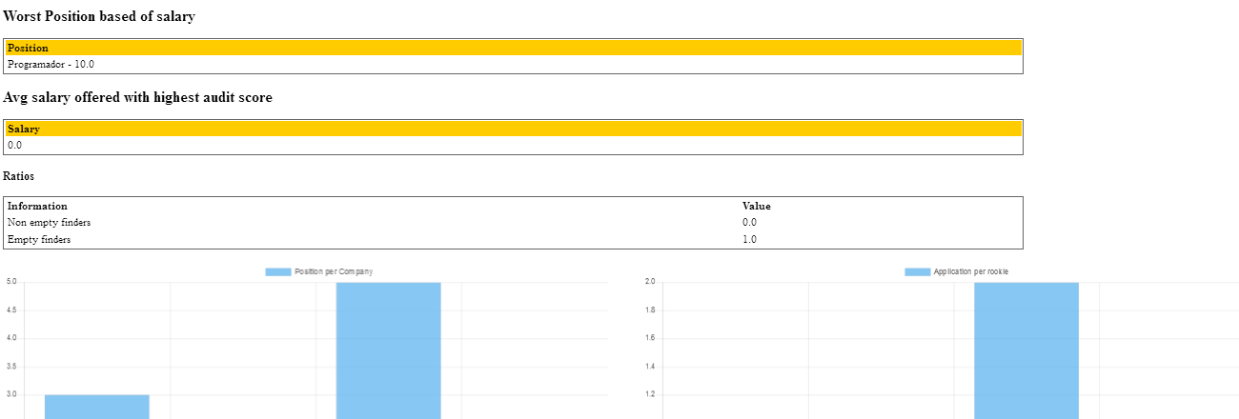

Tests

|  |  |
| --- | --- |
| **Test 001** | |
| **Description** | An admin can display the dashboard. |
| **Expected** | The system must return to a view with the dashboard. |
| **Outcome** | El sistema muestra la dashboard, aunque no coincide con la que se muestra en la imagen anterior. |
| **Notes** |  |

|  |  |
| --- | --- |
| **Test 002** | |
| **Description** | A non admin or a non-authenticated actor tries to access to the dashboard by URL. |
| **Expected** | The system must return to index view. |
| **Outcome** | El sistema redirige a la página de login. |
| **Notes** |  |

# Use case UC38 Calculate spammers, compute companies audit score and send rebranding notification.

Description

An admin can calculate spammers, compute companies audit score and send rebranding notification

Access

Login > Main menu > Profile > Dashboard



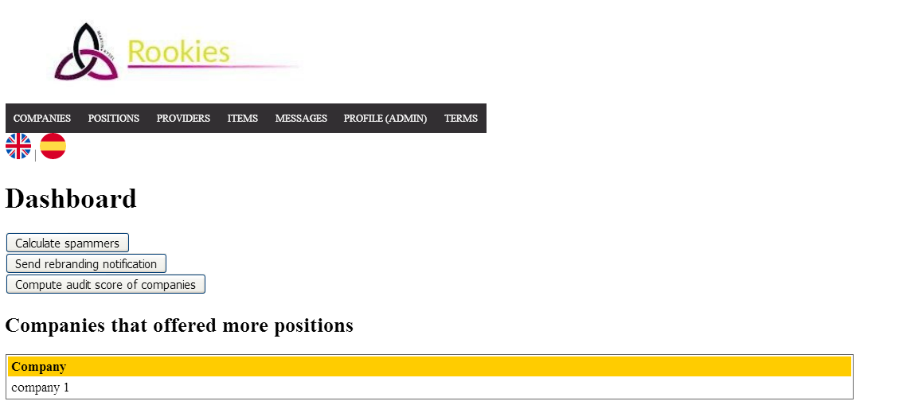Tests

|  |  |
| --- | --- |
| **Test 001** | |
| **Description** | An admin calculates spammers. |
| **Expected** | The system must calculate spammers and return the dashboard. |
| **Outcome** | El sistema se comporta como se espera. |
| **Notes** |  |

|  |  |
| --- | --- |
| **Test 002** | |
| **Description** | An admin calculates companies audit score. |
| **Expected** | The system must calculate audit score and return to the dashboard. |
| **Outcome** | El sistema se comporta como se espera. |
| **Notes** |  |

|  |  |
| --- | --- |
| **Test 003** | |
| **Description** | An admin sends rebranding notification. |
| **Expected** | The system must send a notification to all the users of the system about the rebrand of the system. |
| **Outcome** | El sistema envía la notificación |
| **Notes** |  |

# Use case UC39 Ban actors

Description

An admin can ban suspicious actors

Access

Login > Main menu > Profile > Suspicious actor

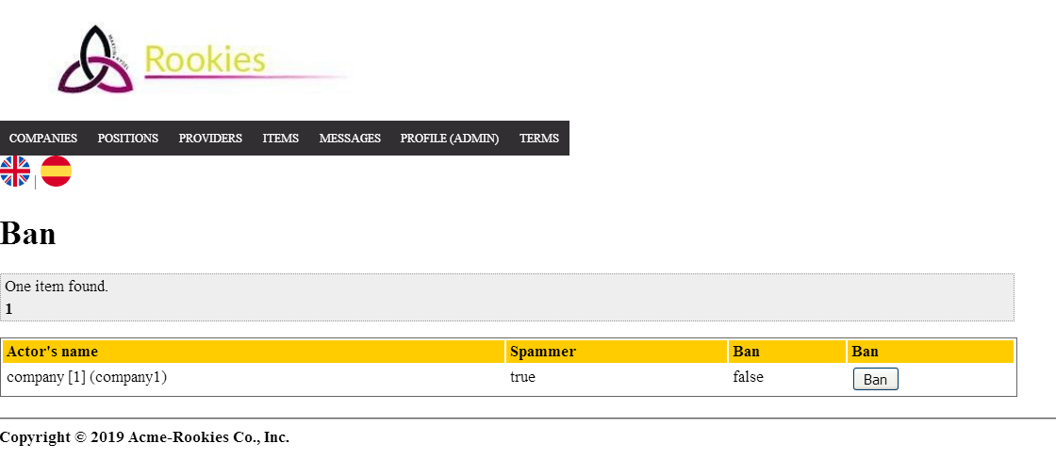

Tests

|  |  |
| --- | --- |
| **Test 001** | |
| **Description** | An admin can ban suspicious actor. |
| **Expected** |  |
| **Outcome** | El sistema banea al usuario |
| **Notes** |  |

|  |  |
| --- | --- |
| **Test 002** | |
| **Description** | An admin can unban banned actors. |
| **Expected** |  |
| **Outcome** | El sistema desbanea al usuario. |
| **Notes** |  |

# Use case UC40 List audits from positions.

Description

A user wishes to list the audits from a position.

Access

Main menu > Positions > Audits

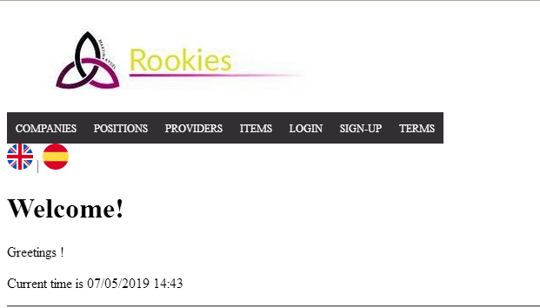

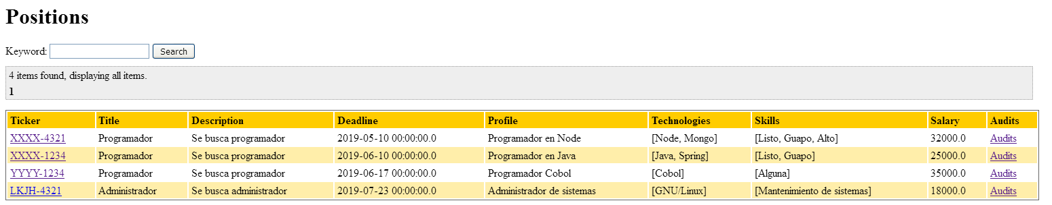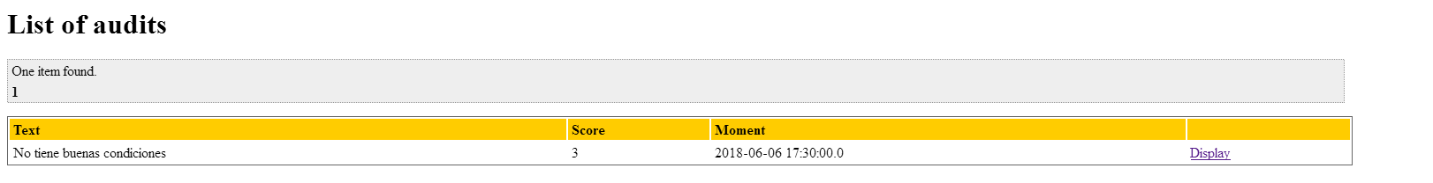

Tests

|  |  |
| --- | --- |
| **Test 001** | |
| **Description** | A user can browse through the audits of a position when is shown. |
| **Expected** | The system must return to a view where shows a list of audits from that position. |
| **Outcome** | El sistema lista las auditorías de la posición. |
| **Notes** |  |

|  |  |
| --- | --- |
| **Test 002** | |
| **Description** | A user logged as an auditor(auditor1/auditor1) lists the audits from one of his positions. |
| **Expected** | The system must return to a view where shows a list of audits from that position. The list includes the audits and a column of final mode and a create link. |
| **Outcome** | El sistema muestra la lista con los datos y link esperados. |
| **Notes** |  |

# Use case UC41 Display an audit.

Description

A user wishes to display an audit.

Access

Main menu > Positions > Audits > Display



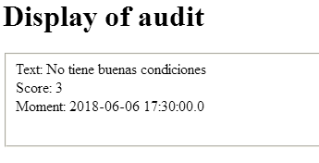

Tests

|  |  |
| --- | --- |
| **Test 001** | |
| **Description** | A user can browse through the audits of a position when is shown and can display them when are in final mode. |
| **Expected** | The system must return to a view where shows the display of the audit with the fields: ‘Text, score and moment’. |
| **Outcome** | El sistema muestra los datos de la auditoria. |
| **Notes** |  |

|  |  |
| --- | --- |
| **Test 002** | |
| **Description** | A user logged as an auditor(auditor1/auditor1) audits from one of his positions. |
| **Expected** | The system must return to a view where shows the display of the audit with the fields: ‘Text, score and moment’. If the Audit is in draft mode a link to edit must be showed. |
| **Outcome** | El sistema muestra los datos de la auditoria. |
| **Notes** |  |

# Use case UC42 Create an audit.

Description

A user logged as an auditor wishes to create an audit to one of his positions.

Access

Login > Main menu > My Positions > Audits > Create > Save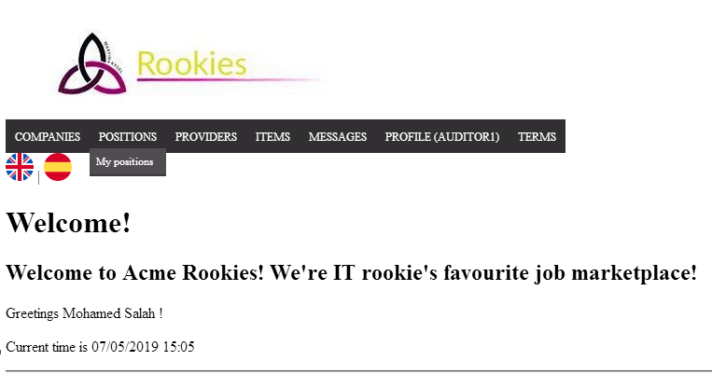

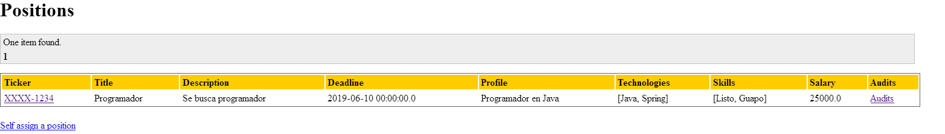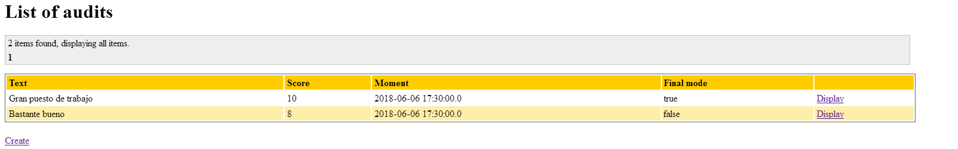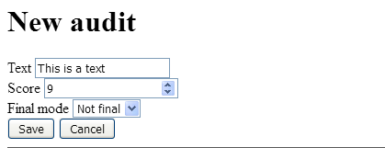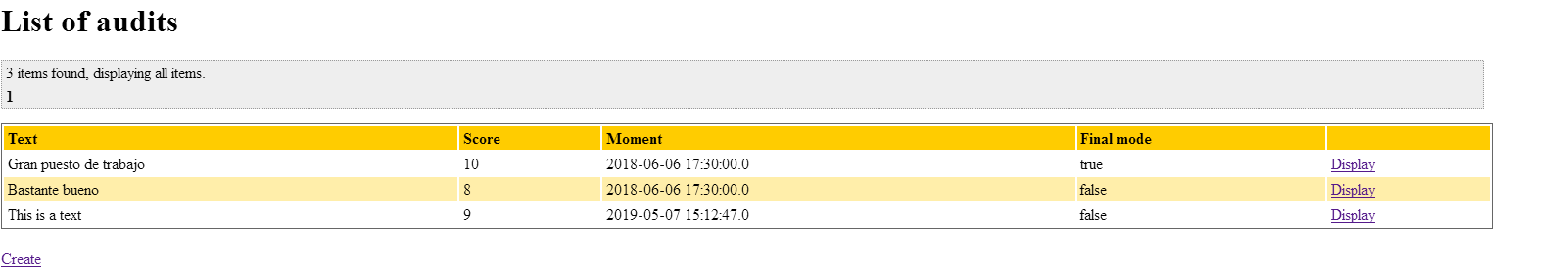 Tests

|  |  |
| --- | --- |
| **Test 001** | |
| **Description** | A user logged as an auditor can create an audit, filling the form correctly (text, score and select the final mode). |
| **Expected** | The system must return to a view where shows a list of audits from the position with the new audit created included. |
| **Outcome** | El sistema crea la auditoria y redirige a la lista de las mismas, donde aparece la creada. No aparece el botón “cancel” como en la imagen. |
| **Notes** |  |

|  |  |
| --- | --- |
| **Test 002** | |
| **Description** | An user logged as an auditor creates an audit filling the form with invalid data (text in blank, score = -1 ). |
| **Expected** |  |
| **Outcome** | Se muestran los errores esperados. |
| **Notes** |  |

# Use case UC43 Edit an audit.

Description

A user logged as an auditor wishes to edit an audit that is in draft mode.

Access

Login > Main menu > My Positions > Audits > Display > Edit > Save

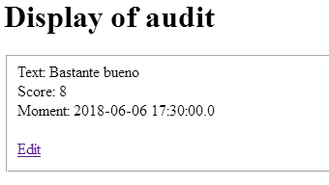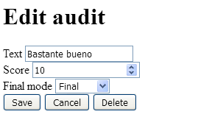

Tests

|  |  |
| --- | --- |
| **Test 001** | |
| **Description** | A user logged as an auditor can edit an audit, filling the form correctly (text, score and select the final mode). |
| **Expected** | The system must return to a view where shows the list of audits from the position with the changes on the audit. |
| **Outcome** | El sistema edita la auditoria y redirige a la lista de las mismas. Pero no se dispone de un botón “cancel” como aparece en la imagen. |
| **Notes** |  |

|  |  |
| --- | --- |
| **Test 002** | |
| **Description** | A user logged as an auditor edits an audit filling the form with invalid data (text in blank, score = -1 ). |
| **Expected** |  |
| **Outcome** | Se muestran los errores esperados. No aparece el botón “cancel” como en la imagen. |
| **Notes** |  |

|  |  |
| --- | --- |
| **Test 003** | |
| **Description** | A user logged as an auditor tries to enter the edit view via post with an audit id that is in final mode. |
| **Expected** | The system must return the user to the welcome page. |
| **Outcome** | El sisteme redirige a la vista de login. |
| **Notes** |  |

# Use case UC44 Delete an audit.

Description

A user logged as an auditor wishes to delete an audit that is in draft mode.

Access

Login > Main menu > My Positions > Audits > Display > Edit > Delete



Tests

|  |  |
| --- | --- |
| **Test 001** | |
| **Description** | A user logged as an auditor can delete an audit that is in draft mode. |
| **Expected** | The system must return to a view where shows the list of audits from the position without the audit deleted. |
| **Outcome** | El sistema elimina la auditoria y muestra la lista de auditorías sin la eliminada. |
| **Notes** |  |

# Use case UC45 Edit configuration.

Description

A user logged as an admin wishes to edit the configuration of the system.

Access

Login > Main menu > Profile(Configuration) > Edit > Save

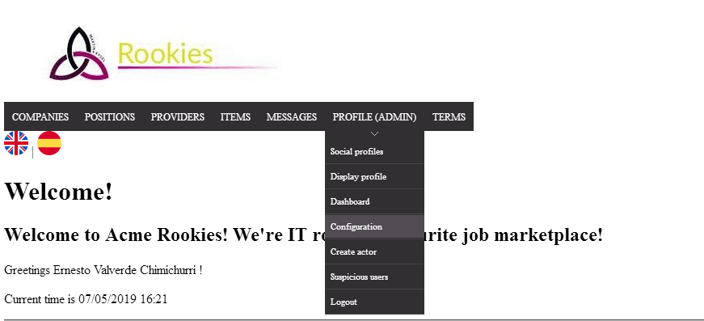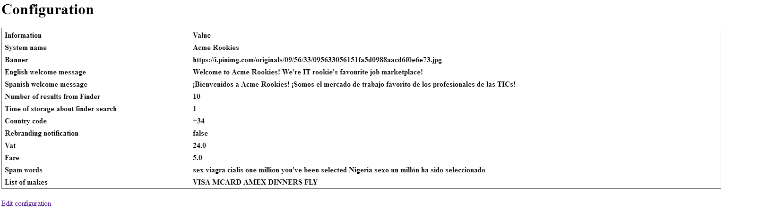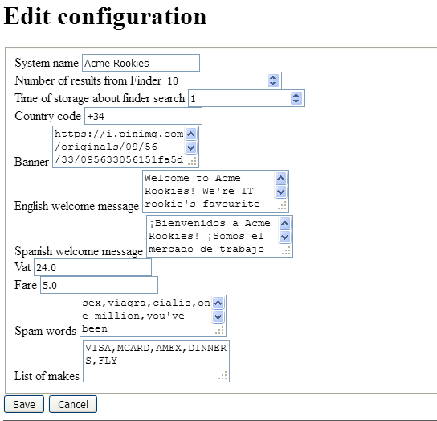

Tests

|  |  |
| --- | --- |
| **Test 001** | |
| **Description** | A user logged as an admin can edit the configuration of the system filling valid data in the form. |
| **Expected** | The system must return to a view where shows the configuration of the system with the changes applied. |
| **Outcome** | El sistema aplica los cambios y muestra los datos de configuración con dichos cambios, pero los campo “English welcome message” y “Spanish welcome message” aparecen con los mensajes esperados cambiados. |
| **Notes** |  |

|  |  |
| --- | --- |
| **Test 002** | |
| **Description** | A user logged as an admin tries to edit the configuration, filling the form with invalid data(text areas in blank and number areas in negative values). |
| **Expected** |  |
| **Outcome** | Se muestran los errores esperados |
| **Notes** |  |

|  |  |
| --- | --- |
| **Test 003** | |
| **Description** | A user logged as an admin edits the configuration, filling the form with a new System Name, after saving the rebranding notification field must be true. |
| **Expected** |  |
| **Outcome** | El sistema pone a “true” dicho campo. |
| **Notes** |  |

# Use case UC46 List applications.

Description

A user logged as a rookie/company wishes to list his/her applications .

Access

Login > Main menu > Applications

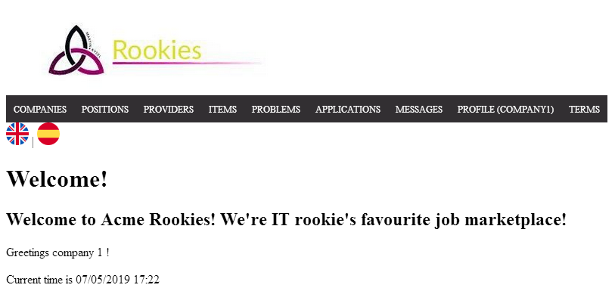

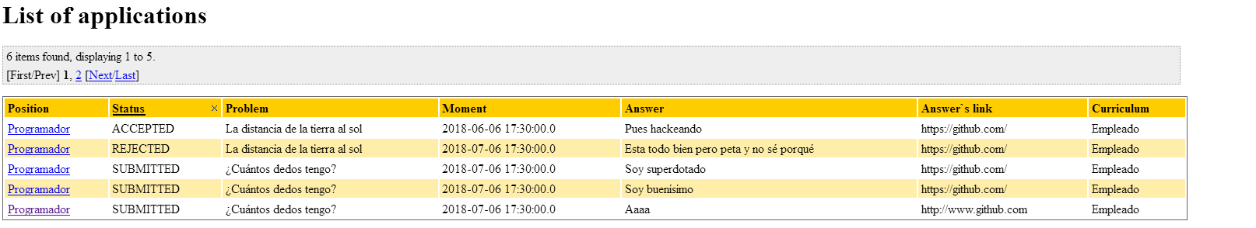 Tests

|  |  |
| --- | --- |
| **Test 001** | |
| **Description** | A user logged as a company/rookie can list their applications. |
| **Expected** | The system must return to a view where shows a list of applications of the logged user. |
| **Outcome** | El sistema lista las aplicaciones del usuario. |
| **Notes** |  |

|  |  |
| --- | --- |
| **Test 002** | |
| **Description** | A user logged as a company/rookie can list their applications and order them by STATUS by clicking on the column. |
| **Expected** | The system must return to a view where shows a list of applications ordered by the status. |
| **Outcome** | El sistema permite ordenar las aplicaciones por estado. |
| **Notes** |  |

# Use case UC47 Create an application.

Description

A user logged as a rookie wishes to create an application to one of the positions.

Access

Login > Main menu > Positions > Display > Save

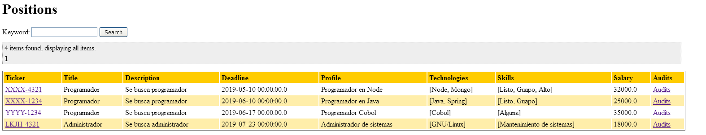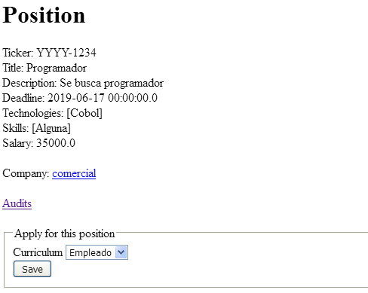

Tests

|  |  |
| --- | --- |
| **Test 001** | |
| **Description** | An user logged as a rookie displays a position and if he can apply for it, the system display a form to select a curriculum and a button to submit it. |
| **Expected** | The system must return to a view where shows a list of the applications made by the logged user with the new application created included. |
| **Outcome** | El sistema crea la aplicación a esa posición y redirige a la lista de aplicaciones del usuario, incluyendo la nueva. |
| **Notes** |  |

# Use case UC48 Edit application.

Description

A user logged as a rookie/company wishes to edit his/her applications .

Access

Login > Main menu > Applications > Display > Edit > Save



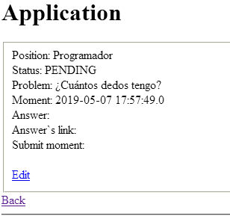

Tests

|  |  |
| --- | --- |
| **Test 001** | |
| **Description** | A user logged as a rookie can edit his application when is in PENDING status to answer the problem assigned and submit it. Filling the form (answer: text, answerLink: https://github.com). |
| **Expected** | After saving it, the user will be redirected to his own list of applications. |
| **Outcome** | El sistema permite editar la aplicación y redirige a la lista de aplicaciones. |
| **Notes** |  |

|  |  |
| --- | --- |
| **Test 002** | |
| **Description** | A user logged as a rookie can edit his application when is in PENDING status to answer the problem assigned and submit it. Filling the form with invalid data with blank values. |
| **Expected** |  |
| **Outcome** | El sistema muestra los errores esperados. |
| **Notes** |  |

|  |  |
| --- | --- |
| **Test 003** | |
| **Description** | A user logged as a rookie can edit his application when is in PENDING status and delete it before is submmited. |
| **Expected** | The user will be redirected to the his list of applications without the deleted application. |
| **Outcome** | El sistema elimina la aplicación y redirige a la lista de aplicaciones donde no aparece la eliminada. |
| **Notes** |  |

|  |  |
| --- | --- |
| **Test 004** | |
| **Description** | A user logged as a company can edit his applications when they are in SUBMITTED status and select to accept/reject it.  (If the status is changed to Accepted, other applications refered to the same position will be rejected). |
| **Expected** | The user will be redirected to the his list of applications applications and the status on that application has changed. |
| **Outcome** | El sistema edita el estado de la aplicación y redirige a la lista de aplicaciones. |
| **Notes** |  |

|  |  |
| --- | --- |
| **Test 005** | |
| **Description** | When a company/rookie enters the edit form they can click the cancel button. |
| **Expected** | The system will redirect the user to his list of applications. |
| **Outcome** | El sistema redirige a la lista de aplicaciones. |
| **Notes** |  |

|  |  |
| --- | --- |
| **Test 006** | |
| **Description** | A company/rookie tries to enter in the edit view with an id that does not exist via url. |
| **Expected** | The system will redirect the user to the welcome page. |
| **Outcome** | El sistema redirige a la vista de login. |
| **Notes** |  |

# Use case UC49 Register as user

Description

An unauthenticated actor wants to register to the system; he or she fills a form with personal data, user account data and extra data depending the type of user selected.

Access

Main Menu > Sign-up.



Tests

|  |  |
| --- | --- |
| **Test 001** | |
| **Description** | The form must not be filled, the selected type of actor is company |
| **Expected** | The system must ask us to confirm the phone.  The system must return the form with the following errors: |
| **Outcome** | El sistema se comporta como se espera y muestra los errores. |
| **Notes** |  |

|  |  |
| --- | --- |
| **Test 002** | |
| **Description** | The form must not be filled, the selected type of actor is rookie. |
| **Expected** | The system must ask us to confirm the phone.  The system must return the form with the following errors: |
| **Outcome** | El sistema se comporta como se espera y muestra los errores. |
| **Notes** |  |

|  |  |
| --- | --- |
| **Test 003** | |
| **Description** | The form must not be filled, the selected type of actor is provider. |
| **Expected** | The system must ask us to confirm the phone.  The system must return the form with the following errors: |
| **Outcome** | El sistema se comporta como se espera y muestra los errores. |
| **Notes** |  |

|  |  |
| --- | --- |
| **Test 004** | |
| **Description** | The form must be filled with the following data:  The password and confirm password must be the same: “companytest” |
| **Expected** | The system must ask us to confirm the phone. |
| **Outcome** | El sistema muestra el error esperado. |
| **Notes** |  |

|  |  |
| --- | --- |
| **Test 005** | |
| **Description** | The form must be filled with the following data:  The password and confirm password must not be the same: “companytest” for password and “otherpass” for confirm, for example. |
| **Expected** | The system must ask us to confirm the phone. |
| **Outcome** | El sistema muestra el error esperado. |
| **Notes** |  |

|  |  |
| --- | --- |
| **Test 006** | |
| **Description** | The form must be filled with the following data:  The password and confirm password must be the same: “companytest” for password for confirm, for example. |
| **Expected** | After confirm the phone, the system give us to the welcome page, and now we are able to log-in with the created user. |
| **Outcome** | El sistema registra el usuario y redirige a la página de inicio. |
| **Notes** |  |

|  |  |
| --- | --- |
| **Test 007** | |
| **Description** | The form must be filled with the following data:  The password and confirm password must be the same: “rookietest” |
| **Expected** |  |
| **Outcome** | El sistema se comporta como se espera y muestra el error. |
| **Notes** |  |

|  |  |
| --- | --- |
| **Test 008** | |
| **Description** | The form must be filled with the following data:  The password and confirm password must not be the same: “rookietest” for password and “otherpass” for confirm, for example. |
| **Expected** |  |
| **Outcome** | El sistema se comporta como se espera y muestra el error. |
| **Notes** |  |

|  |  |
| --- | --- |
| **Test 009** | |
| **Description** | The form must be filled with the following data:  The password and confirm password must be the same: “rookietest” for password for confirm, for example. |
| **Expected** | After confirm the phone, the system give us to the welcome page, and now we are able to log-in with the created user. |
| **Outcome** | El sistema registra al usuario y redirige a la página de inicio. |
| **Notes** |  |

|  |  |
| --- | --- |
| **Test 010** | |
| **Description** | The form must be filled with the following data:  The password and confirm password must be the same: “providertest” |
| **Expected** | The system must ask us to confirm the phone. |
| **Outcome** | El sistema se comporta como se espera y muestra el error. |
| **Notes** |  |

|  |  |
| --- | --- |
| **Test 011** | |
| **Description** | The form must be filled with the following data:  The password and confirm password must not be the same: “providertest” for password and “otherpass” for confirm, for example. |
| **Expected** | The system must ask us to confirm the phone. |
| **Outcome** | El sistema se comporta como se espera y muestra el error. |
| **Notes** |  |

|  |  |
| --- | --- |
| **Test 012** | |
| **Description** | The form must be filled with the following data:  The password and confirm password must be the same: “providertest” for password for confirm, for example. |
| **Expected** | After confirm the phone, the system give us to the welcome page, and now we are able to log-in with the created user. |
| **Outcome** | El sistema registra al usuario y redirige a la página de inicio. |
| **Notes** |  |

# Use case UC50 Create a user being an administrator

Description

An administrator wants to create new administrators or auditors; he or she fills a form with personal data, user account data and extra data depending the type of user selected.

Access

We need to log-in with “admin” “admin” and then go to the create actor section.

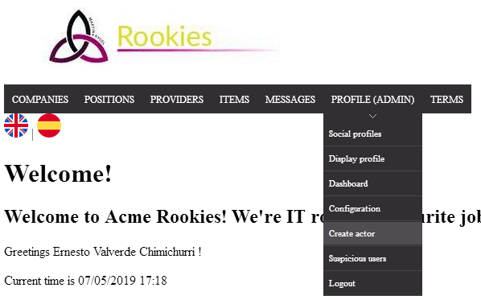

|  |  |
| --- | --- |
| **Test 001** | |
| **Description** | The form must not be filled, the selected type of actor is administrator. |
| **Expected** | The system must ask us to confirm the phone.  The system must return the form with the following errors: |
| **Outcome** | El sistema se comporta como se espera y muestra los errores. |
| **Notes** |  |

|  |  |
| --- | --- |
| **Test 002** | |
| **Description** | The form must not be filled, the selected type of actor is auditor. |
| **Expected** | The system must ask us to confirm the phone.  The system must return the form with the following errors: |
| **Outcome** | El sistema se comporta como se espera y muestra los errores. |
| **Notes** |  |

|  |  |
| --- | --- |
| **Test 003** | |
| **Description** | The form must be filled with a different password in the Password field and the Confirm password field. |
| **Expected** | The system must ask us to confirm the phone.  The system must return the form with the following errors: |
| **Outcome** | El sistema se comporta como se espera y muestra el error. |
| **Notes** |  |

|  |  |
| --- | --- |
| **Test 005** | |
| **Description** | The form must be filled with valid data, you can use the placeholders to help you to find valid data. Select administrator.  The password and confirm password must be the same: “admintest” for password for confirm, for example. |
| **Expected** | After confirm the phone, the system give us to the welcome page, and now we are able to log-in with the created user. |
| **Outcome** | El sistema registra al usuario y redirige a la página de inicio. |
| **Notes** |  |

|  |  |
| --- | --- |
| **Test 006** | |
| **Description** | The form must be filled with valid data, you can use the placeholders to help you to find valid data. Select auditor.  The password and confirm password must be the same: “auditortest” for password for confirm, for example. |
| **Expected** | After confirm the phone, the system give us to the welcome page, and now we are able to log-in with the created user. |
| **Outcome** | El sistema registra al usuario y redirige a la página de inicio. |
| **Notes** |  |

# Use case UC51 Display personal data

Description

A logged user must be able to display his or her personal data.

Access

We need to log-in with the appropriate user and go to the following section:

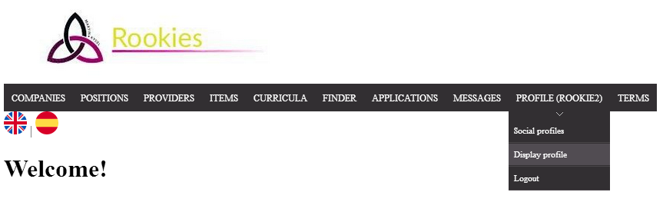

Tests

|  |  |
| --- | --- |
| **Test 1** | |
| **Description** | You must log in with a rookie: “rookie1” “rookie1”. And go to display Profile. |
| **Expected** |  |
| **Outcome** | El sistema muestra los datos del usuario. |
| **Notes** |  |

|  |  |
| --- | --- |
| **Test 2** | |
| **Description** | You must log in with a company: “company1” “company1”. And go to display Profile. |
| **Expected** |  |
| **Outcome** | El sistema muestra los datos del usuario. |
| **Notes** |  |

# Use case UC52 Manage personal data

Description

When a logged user wants to manage his or her personal data.

Access

We need to log-in with the appropriate user and go to the following section:



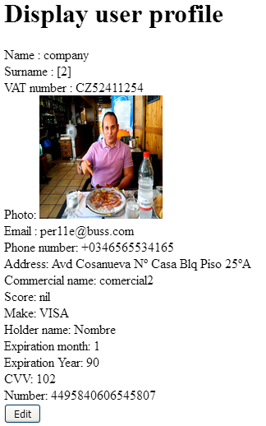

Tests

|  |  |
| --- | --- |
| **Test 001** | |
| **Description** | You must not fill the edit form. |
| **Expected** |  |
| **Outcome** | El sistema muestra los errores esperados. |
| **Notes** |  |

|  |  |
| --- | --- |
| **Test 002** | |
| **Description** | You must make some legal changes on the fields, for example, change the name to “nameTest”, the email to [test@test.com](mailto:test@test.com) and submit the form. |
| **Expected** | The system gives us back to the display and the changes were made. |
| **Outcome** | El sistema edita el perfil del usuario y redirige a la vista del perfil. |
| **Notes** |  |

|  |  |
| --- | --- |
| **Test 003** | |
| **Description** | Click in the cancel button. |
| **Expected** | The system gives us back to the display without changes. |
| **Outcome** | El botón “cancel” redirige a la página de inicio, en lugar del display del usuario. |
| **Notes** |  |

|  |  |
| --- | --- |
| **Test 004** | |
| **Description** | Click in the export data button. |
| **Expected** | A Json with the data of the actor: |
| **Outcome** | El sistema muestra el JSON esperado. |
| **Notes** |  |

|  |  |
| --- | --- |
| **Test 005** | |
| **Description** | Click in the delete button |
| **Expected** | A confirmation if we are sure to delete and then the system gives us back to the welcome page, our user account was deleted from the system. |
| **Outcome** | El sistema elimina al usuario. |
| **Notes** |  |

# Use case UC53 Finder

Description

A rookie has a finder with some filters that help him or her to find positions.

Access

We need to log-in with a rookie user “rookie1” “rookie1” and go to the following section:



Tests

|  |  |
| --- | --- |
| **Test 1** | |
| **Description** | You must not fill any filter and click in the search button. |
| **Expected** | All the positions must be retrieves. |
| **Outcome** | El sistema muestra las posiciones. |
| **Notes** |  |

|  |  |
| --- | --- |
| **Test 2** | |
| **Description** | You must fill the keyword fill, for example with “administrator”, and click in the search button. |
| **Expected** | Positions with “administrator” are given. |
| **Outcome** | El sistema muestra las posiciones filtradas. |
| **Notes** |  |

|  |  |
| --- | --- |
| **Test 3** | |
| **Description** | You must fill the deadline field, for example with “10/05/2019”, and click in the search button. |
| **Expected** | Positions with deadline “10/05/2019” are given. |
| **Outcome** | El sistema muestra las posiciones filtradas. |
| **Notes** |  |

|  |  |
| --- | --- |
| **Test 4** | |
| **Description** | You must fill the max deadline field, for example with “10/06/2019”, and click in the search button. |
| **Expected** | Positions with deadline “10/06/2019” or fewer are given. |
| **Outcome** | El sistema muestra las posiciones filtradas. |
| **Notes** |  |

|  |  |
| --- | --- |
| **Test 5** | |
| **Description** | You must fill the salary field, for example with “30000”, and click in the search button. |
| **Expected** | Positions with at least 30000 salary are given. |
| **Outcome** | El sistema muestra las posiciones filtradas. |
| **Notes** |  |

|  |  |
| --- | --- |
| **Test 6** | |
| **Description** | You must fill all the filters, search, and then click in the clear button. |
| **Expected** | All the filters were cleared. |
| **Outcome** | El sistema muestra las posiciones sin filtros y borra los campos del filtro. |
| **Notes** |  |

|  |  |
| --- | --- |
| **Test 7** | |
| **Description** | You must click in the cancel button. |
| **Expected** | The system gives us to the welcome page. |
| **Outcome** | El sistema redirige a la página principal. |
| **Notes** |  |

# Use case UC54 List of companies

Description

Every actor of the system can list the companies and navigate to their positions.

Access

By clicking in the field “Companies” in the navigation bar.

Tests

|  |  |  |
| --- | --- | --- |
| **Test 001** | | |
| **Description** | A logged or non-logged actor wants to see the companies. | |
| **Expected** | A list page with companies. | |
| **Outcome** | El sistema list alas companies existentes. | |
| **Notes** |  | |
| **Test 002** | | |
| **Description** | | The actor clicks in the name of the company. |
| **Expected** | | The system gives him or her the display of the company. |
| **Outcome** | | El sistema muestra los datos de la company seleccionada. |
| **Notes** | |  |

|  |  |
| --- | --- |
| **Test 003** | |
| **Description** | The actor clicks in the positions link |
| **Expected** | The system gives him or her a list of the positions of the company. |
| **Outcome** | El sistema list alas posiciones de la company seleccionada. |
| **Notes** |  |

# Use case UC55 List of providers

Description

Every actor of the system can list the providers and navigate to their items.

Access

By clicking in the field “Providers” in the navigation bar.

Tests

|  |  |
| --- | --- |
| **Test 001** | |
| **Description** | A logged or non-logged actor wants to see the providers. |
| **Expected** | A list page with providers. |
| **Outcome** | El sistema lista los proveedores existentes. |
| **Notes** |  |

|  |  |
| --- | --- |
| **Test 002** | |
| **Description** | The actor clicks in the name of the provider. |
| **Expected** | The system gives him or her the display of the provider. |
| **Outcome** | El sistema muestra los datos del proveedor seleccionado. |
| **Notes** |  |

|  |  |
| --- | --- |
| **Test 003** | |
| **Description** | The actor clicks in the items link. |
| **Expected** | The system gives him or her a list of the items of the company. |
| **Outcome** | El sistema lista los items del proveedor seleccionado. |
| **Notes** |  |

# Additional tests

|  |  |
| --- | --- |
| **Test 001** | |
| **Description** | “Change the language to Spanish”. |
| **Expected** | Every message displayed by the system must be in Spanish. |
| **Outcome** | El sistema se traduce al español. |
| **Notes** |  |